Tennis Lab assignment 3

Victoria University

Footscray Park Campus

Jayden Hardie

S4259178

**User Manual**

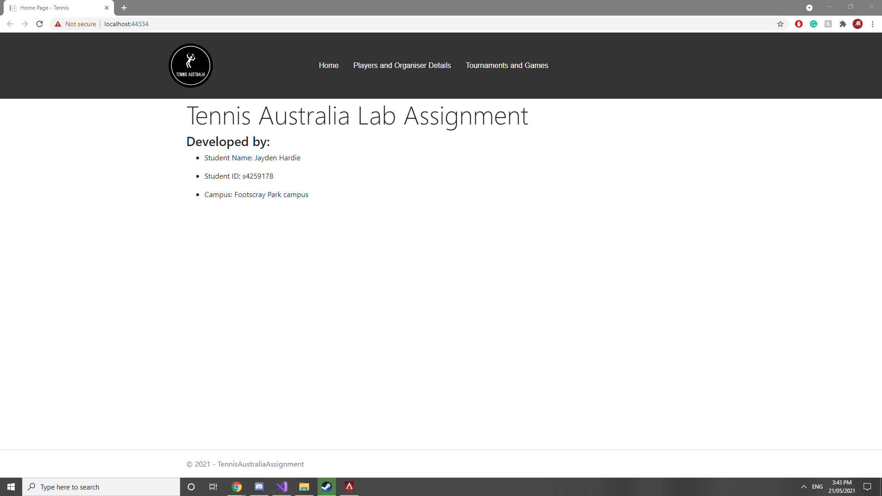

When the user first loads the Tennis Australian Admin site they are greeted with the above image, in this screen the user will first notice a navigation section, the Australian tennis logo and other details such as the developer of the application.

However for now will focus on the navigation section at the top of the screen, when the user mouses over either the “Players and Organiser details” or the “Tournaments and Games” sections the icon will turn to a red background and a drop down list will appear as the two below images demonstrate.

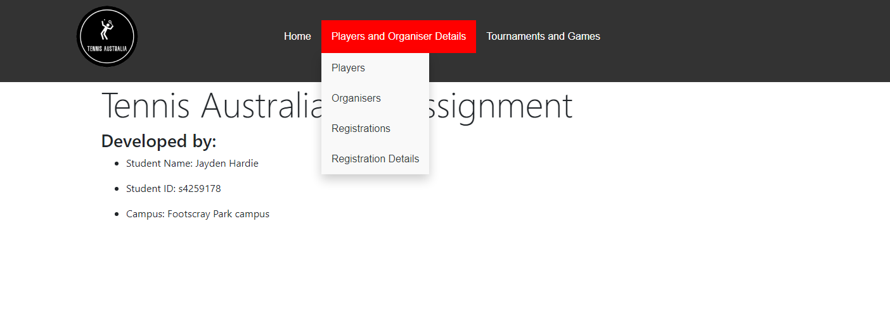

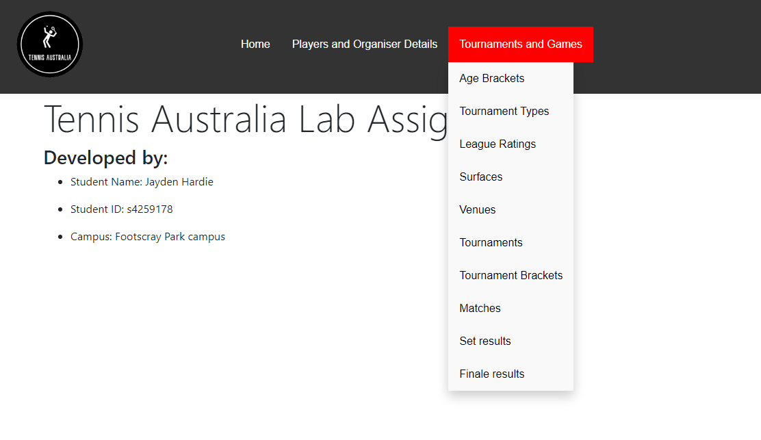

The first thing the user will know when they see these drop down menus is a list of different categories, for this the “Players and Organiser details” involves all the databases related to the aforementioned name, while the “Tournaments and Games” deals with all the databases that involve the tournament systems, matches and outcomes. However, for convenience and to make it easier for the user, it is advised that the user first start filling in the “Players and Organiser details” from the top listed category to the bottom one before moving onto “Tournaments and Games” and repeating top to bottom. The reason the system is like this is to ensure that before moving onto a certain category all the required databases are filled out hence if a user works in this system they will never have an issue with needing to back track.

**Player**

Next will start the process of explaining the databases associated with the application and what each category is for and the purpose of the databases, if the user follows this section by section they should have no issue filling out the database. To start off with will start with the Players database. The purpose of the player database is to store and maintain the details of the players, in this database it is made up of the players tennis membership number, australia ranking and universal tennis rating which are the categories responsible for identifying the player in terms of placement. While next we have the personal details such as name, age, address details and contact information to identify and contact the players.

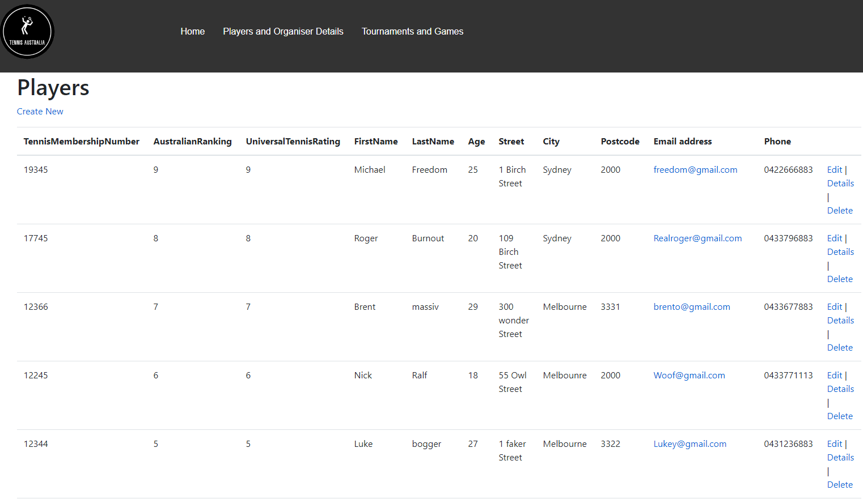

If the user wishes to make an entry they can press the button “Create New” that is under the Players Title to insert a new entry, the following image is the create page the user will be taken to, to fill out the details of a player.

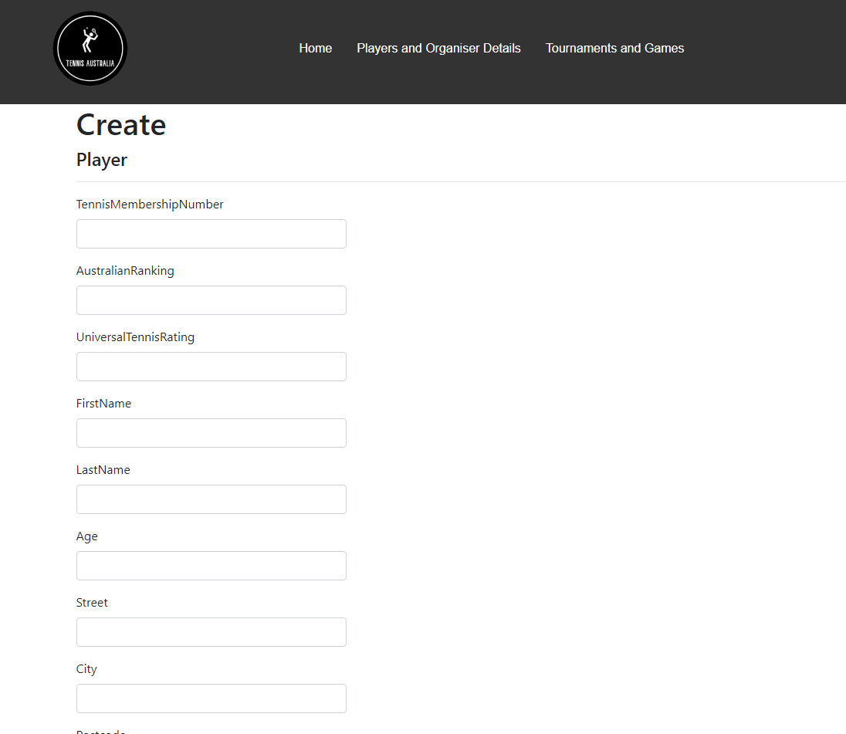

If however the user would like to access the details,edit or delete an entry on the right hand side of the first image is the button that allows the user to carry out that action with pictures of these options shown below.



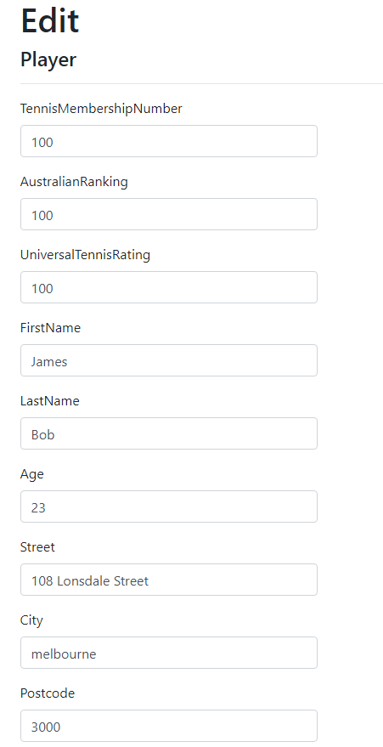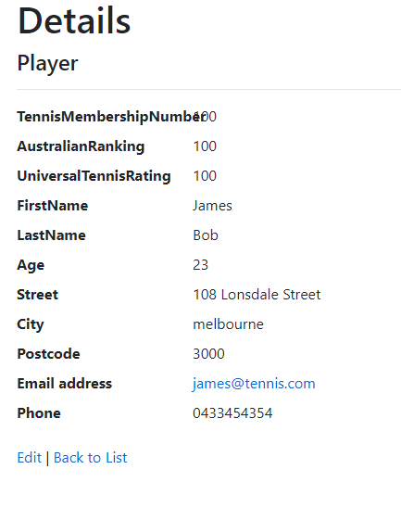

**Organiser**

Similar to the player table is the Organiser table, this table encompasses everything that is required to fill out the details of the organisers of the tournaments and games. Much like the Player table in that it too asks for the personal details of a name, address and contact details as both the organiser and player databases are inherited from a shared database that cant be access directly through links known as the personal details database and requires the user input the phrase “PersonalDetails” into the URL to access it. However because the table offers nothing beyond want the two tables have it is left out and is of no use to access directly.

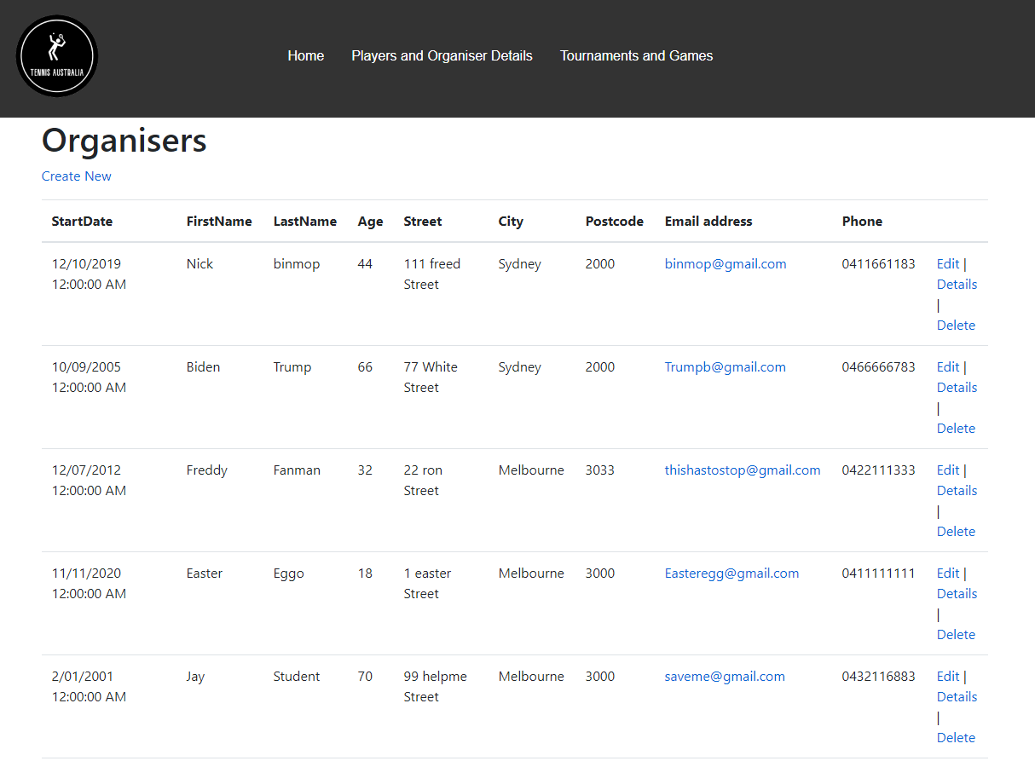

Again for the creation of an entry the option is under the title of organisers for the user to make a new organiser entry, while on the right hand side are the options of edit, details and deletion of an entry with pictures below showing these screens.

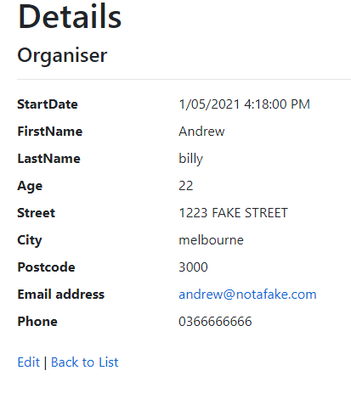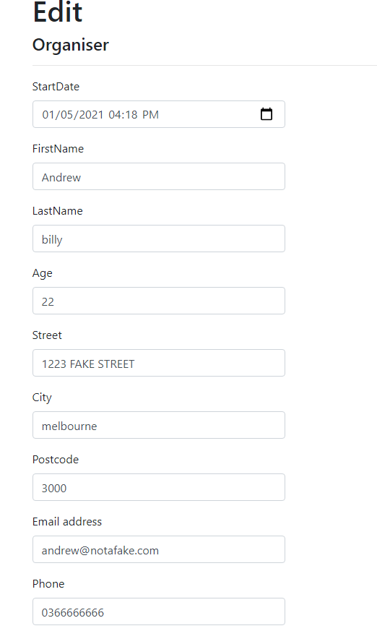

**Registration**

The registration list database is to serve as the database responsible for players to register to a tournament, each player will only be able to have one registration ID for solo matches and another for duo matches, these ID’s will carry onto any tournament and be used to identify the player however for the combination of players to registration ID is carried out in another table. For this table is to serve as the creation of the ID’s and the date and time they were made.

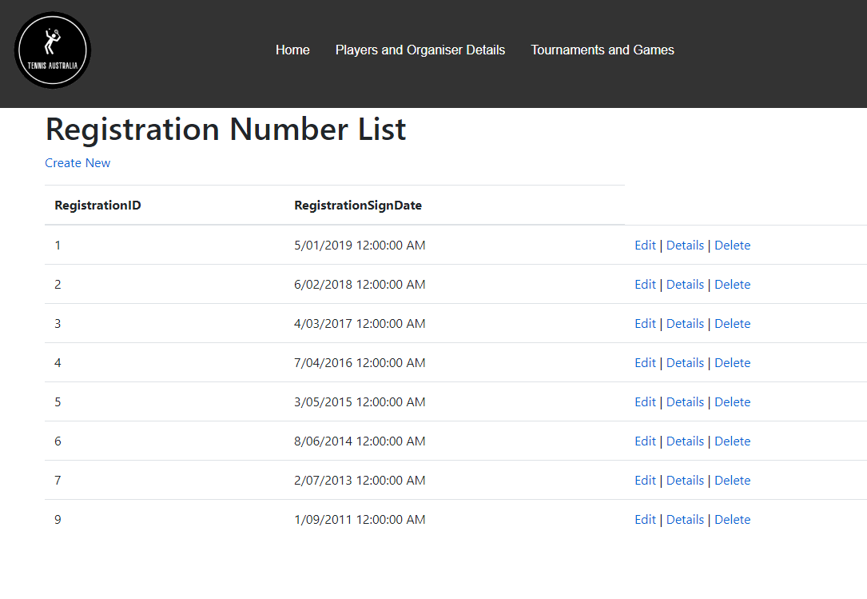

Again there is the option for the user to create a new entry under the title of the page and the options of edit, details and delete on the right hand side to make alterations to the database. However unlike the previous tables the following table has access to calendar and time in addition to the already seen creation features as seen below, the user can simply just click and select the appropriate time and date for the ID.

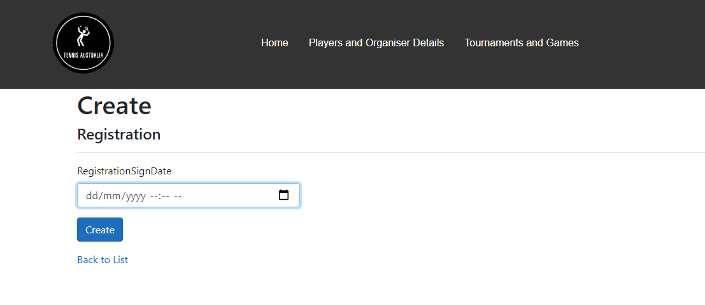

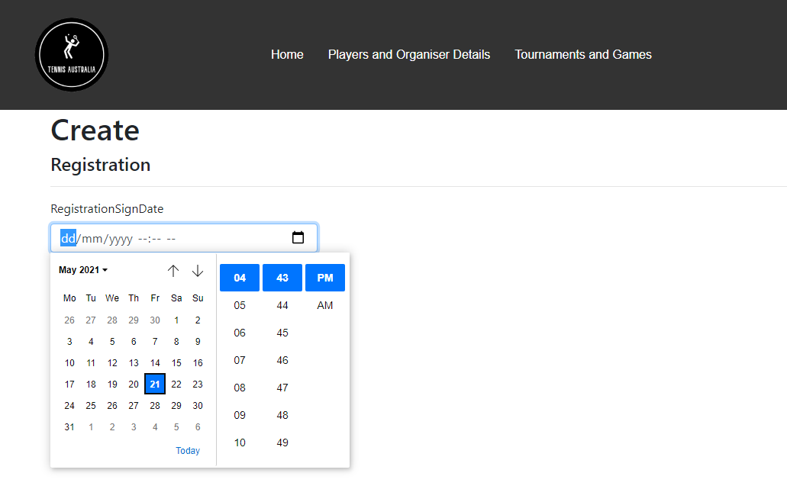

While the following images showcase the edit and details sections of the registration database.

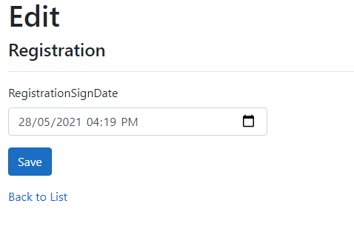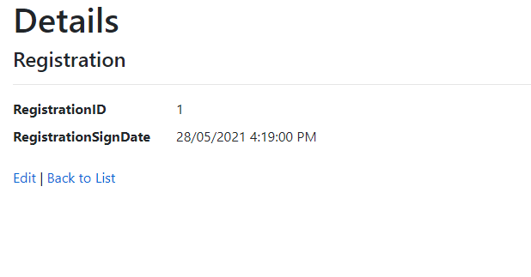

**Registration Details**

This database carries out the aforementioned assigning of players to their registration ID and records the ID of the registration and Player full name as seen below.

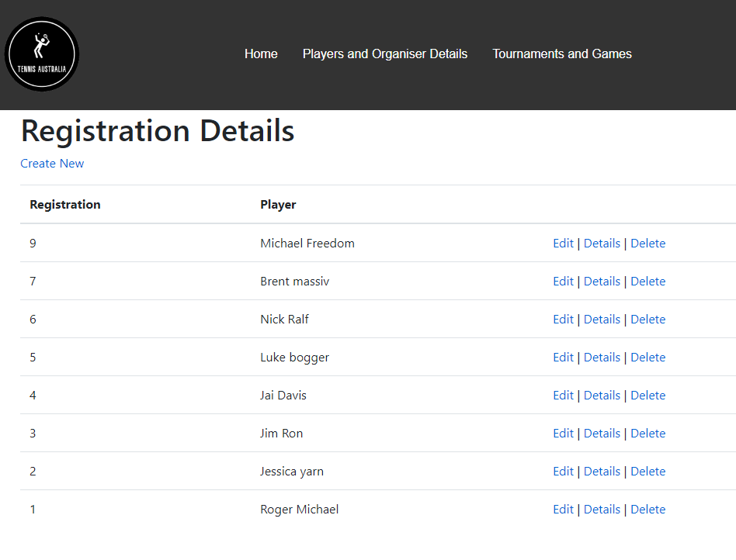

For the following section the user again can create a new entry with the create new button under the title and the options for editing, details and deletion of an entry are on the right hand side. However unlike other creation entries so far the user will not have to manually fill out the names of the players but rather is presented with a choice of the players to pick from as shown below.

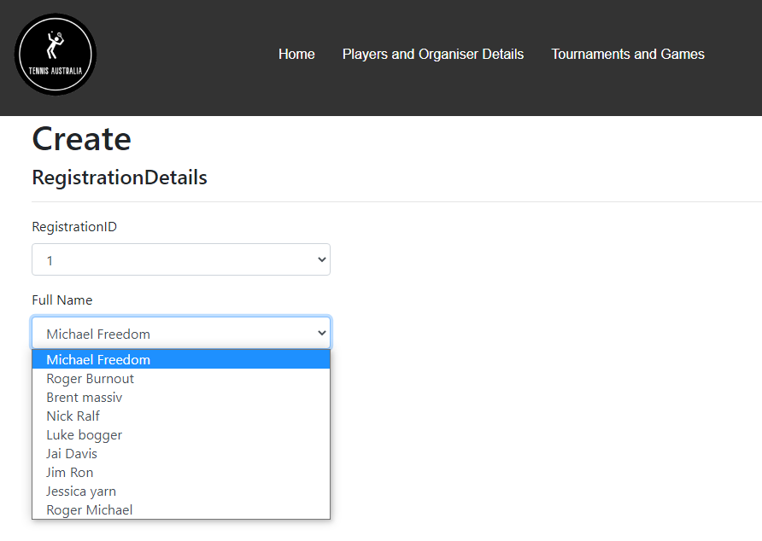

While the following images showcase the edit and details sections of the registration database.

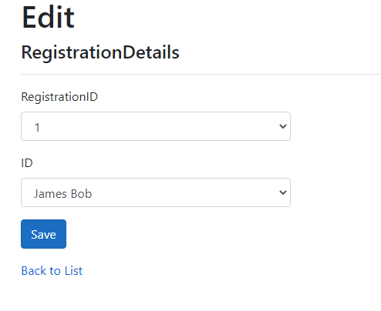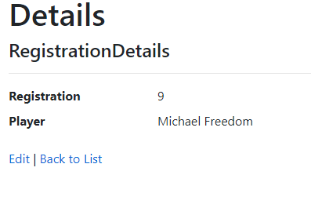

**Age Bracket**

This database serves as the recording of different age brackets that can be present in a tournament and hence the database records the name and description of the age bracket as shown below.

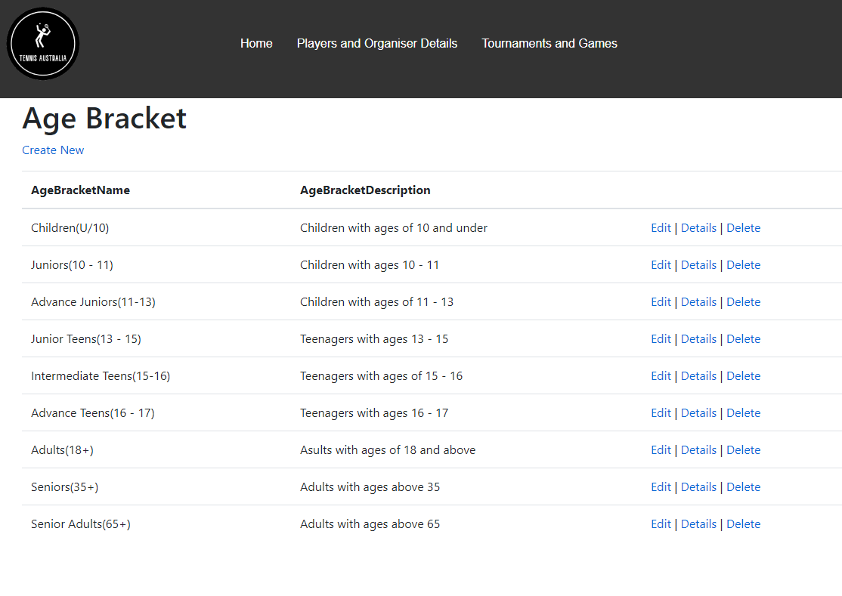

While if the user wishes to create an entry the option exists under the title and the options of edit, details and deletion of an entry are on the right hand side with the following pictures showcasing the edit and details section.

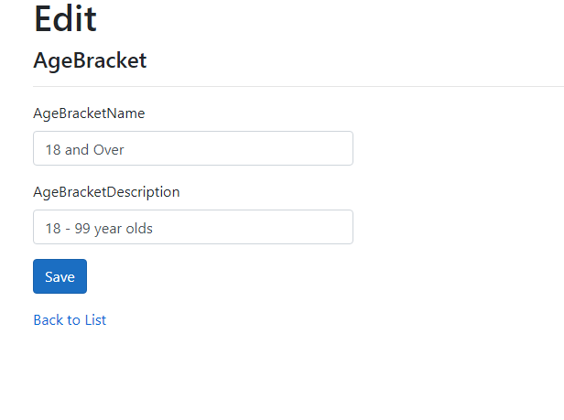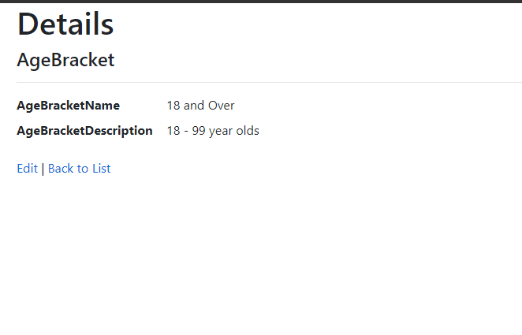

**Tournament Types**

The database of Tournament Types serves to act as a record of the different types of tournaments that can exist such as AMT which is a prize pool tournament or JRN which is a tournament for juniors, this database is the section to define their name and description as seen below.

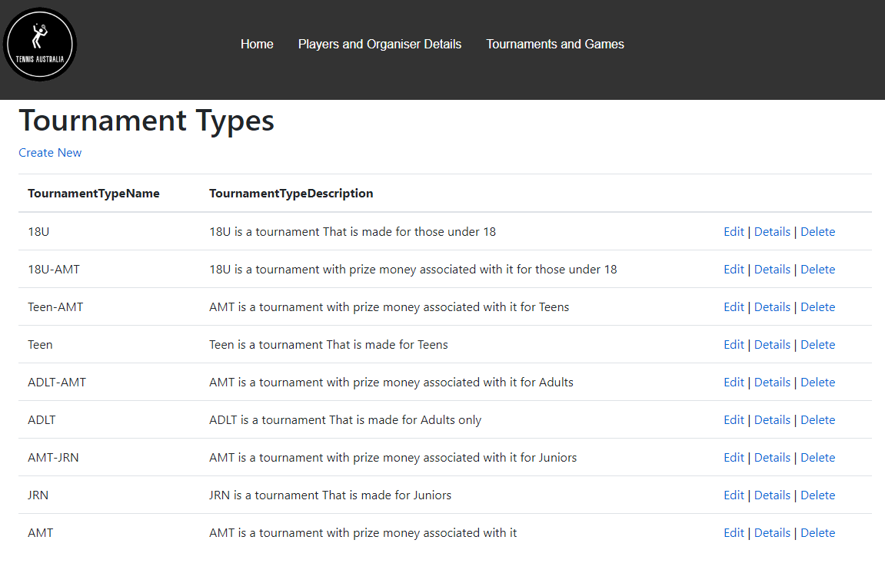

Like other tables the option for creation of a table exists under the title of the page while the options for edit, details and deletion of an entry exist on the right hand side while the following images showcase the edit and details section of the database.

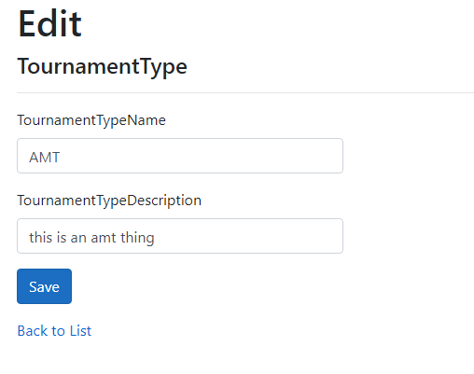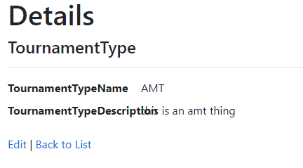

**League Ratings**

The league ratings database serves to act as a list of the rankings or tournaments that can exist to properly grade players appropriately as seen below the only option for the user is to assign a name.

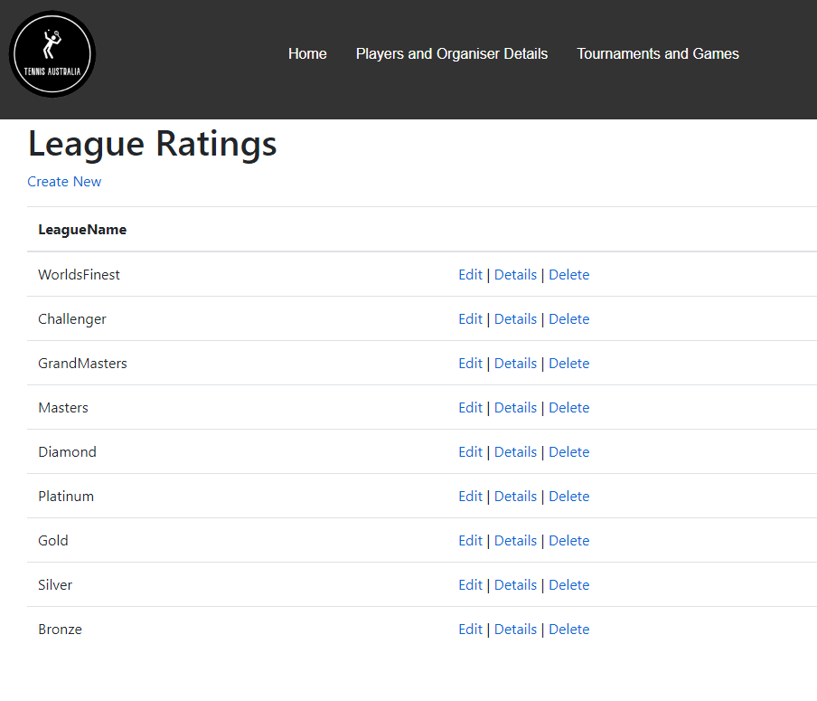

The creation of entries for this section can be found under the title while the options for edit, details and deletion can be found on the right hand side with the following images showing the edit and details section of the database.

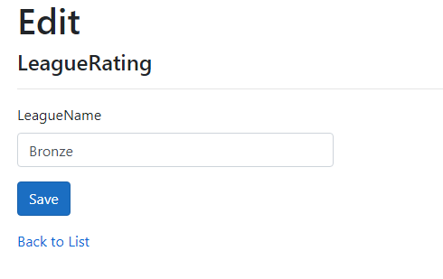

**Surfaces**

The surfaces database serves as the reference to the different types of surfaces a venue will have a choice to pick from when creating a venue and for this database it will record down the name of the surface and its description of what the surface will present in terms of challenges to consider when playing on that type of surface as seen below.

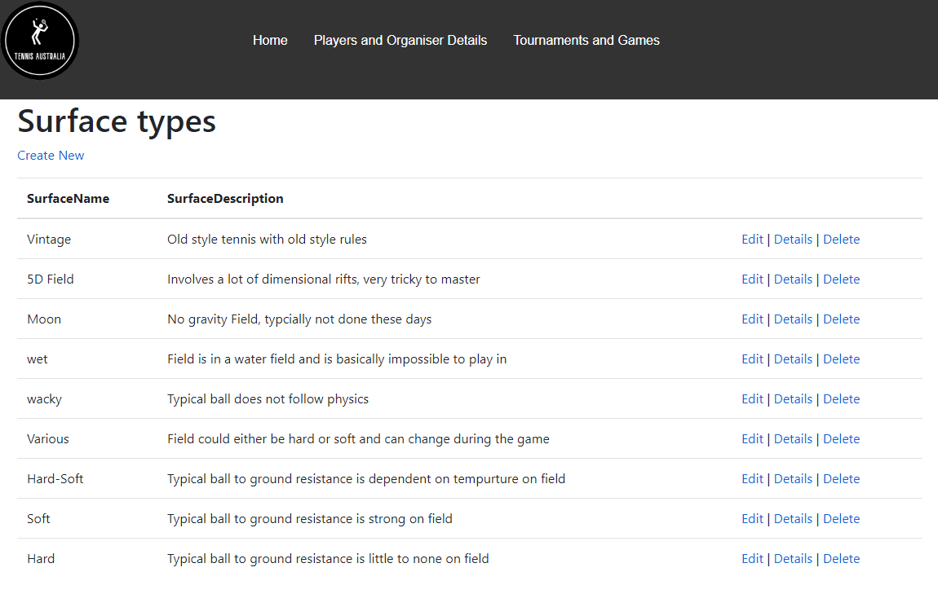

The option for creation of this database exists under the title with the options of edit, details and deletion on the right hand side with the following images showcasing the edit and details sections.

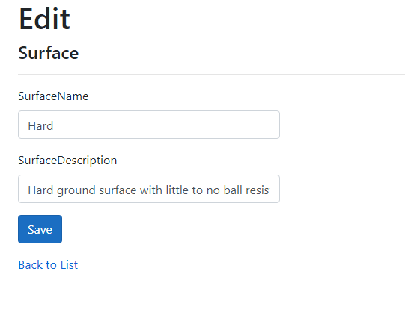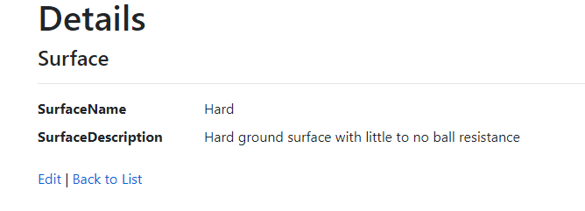

**Venue**

This database serves as details of the venue that tournaments are to be held at, for this the database will record the details of name, address, state and the type of surface as seen below.

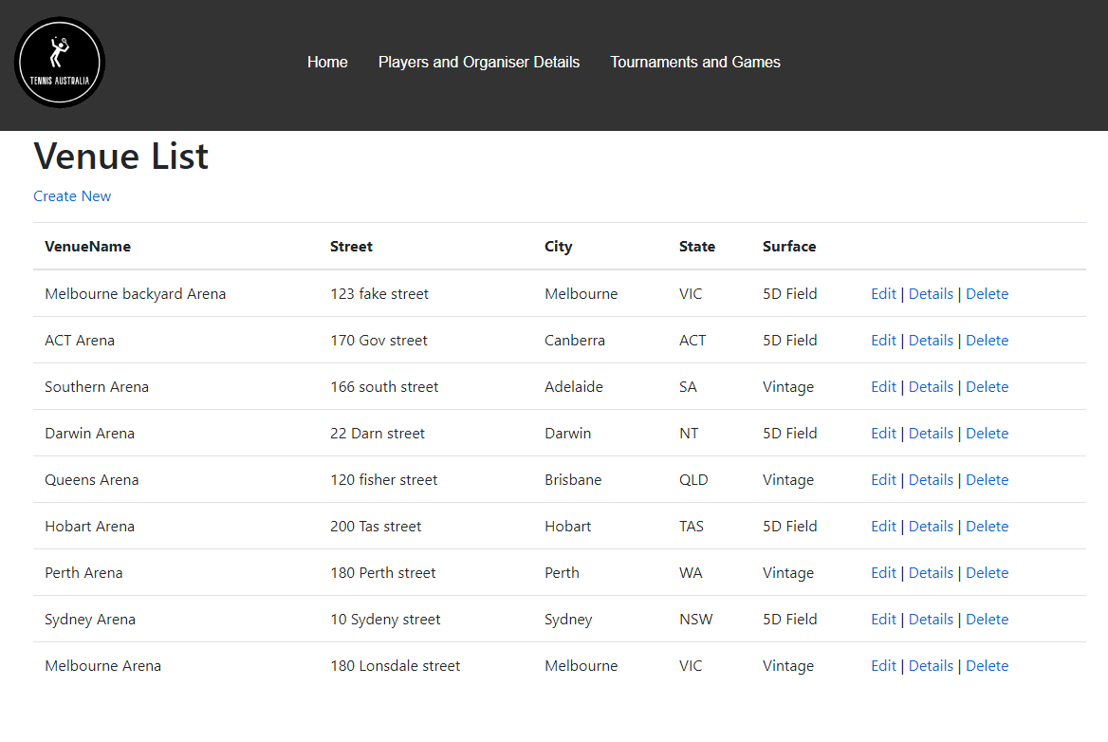

However much like the registration details database the user when creating an entry they will be given the option to pick out the surface based on what is in the surface database as seen below.

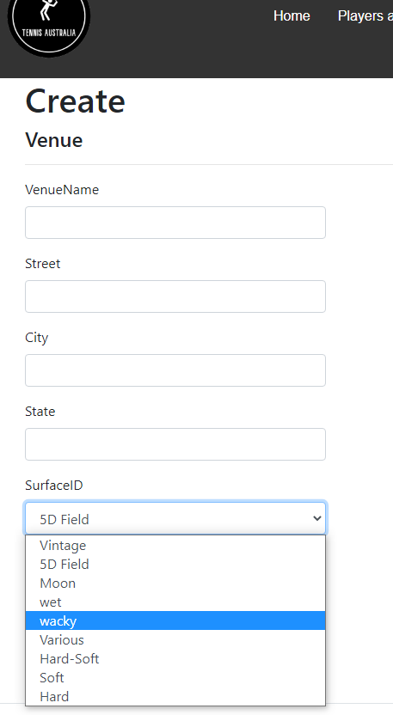

While in terms of edit, details and deletion of an entry as seen in the below table they can be found on the right hand side of the page of the first image below, while the following images after showcase show the edit and details sections of the database.



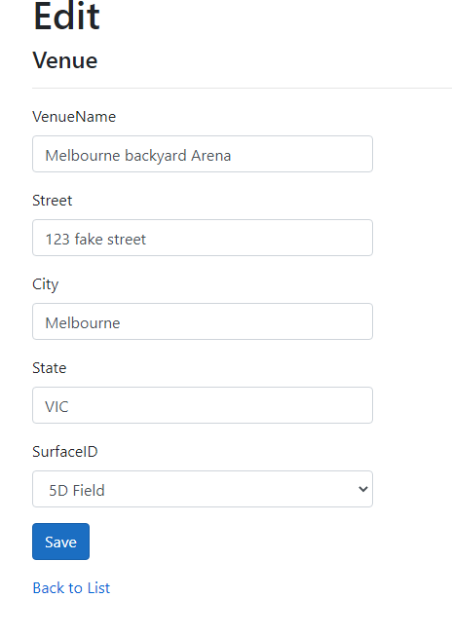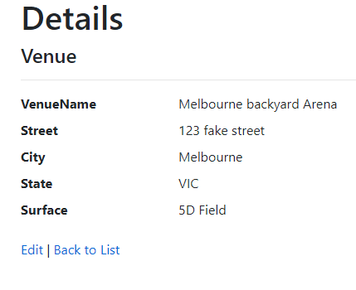

**Tournaments**

The following database serves as a record of the tournaments and as such records the details of tournament name, if the tournament is a qualifier, in that is the tournament a precursor to another tournament, the start and end dates of the tournament, the signup and end dates of the tournament. While also including details for the prize money, venue, tournament type and the organiser of the tournament.

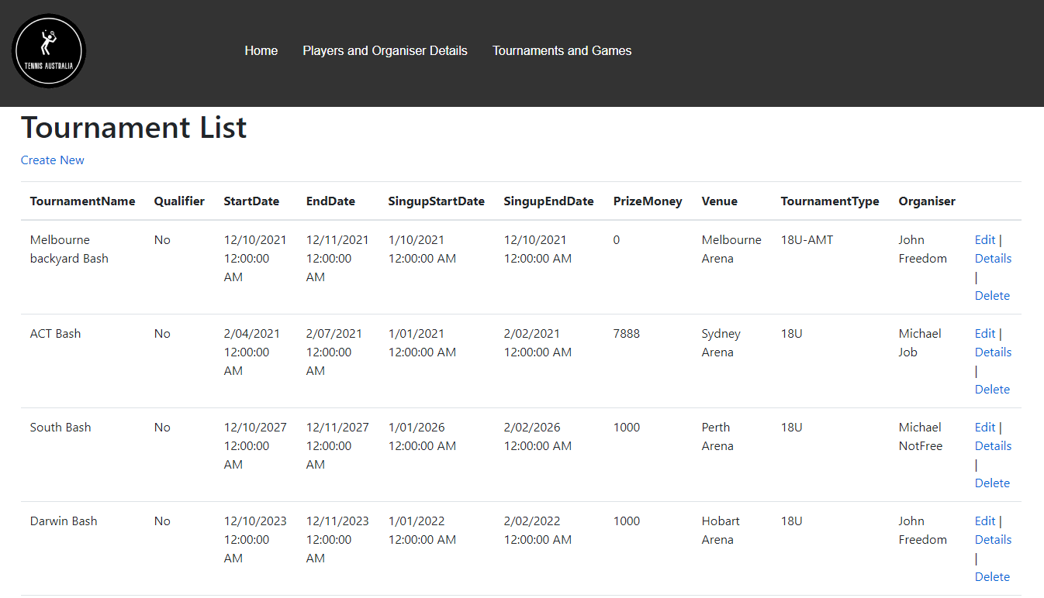

While the editing, details and deletion of an entry are on the right, for this table when creating an entry the user will again have the option for date and time selection and also to pick a venue, tournament type and organiser as seen below.

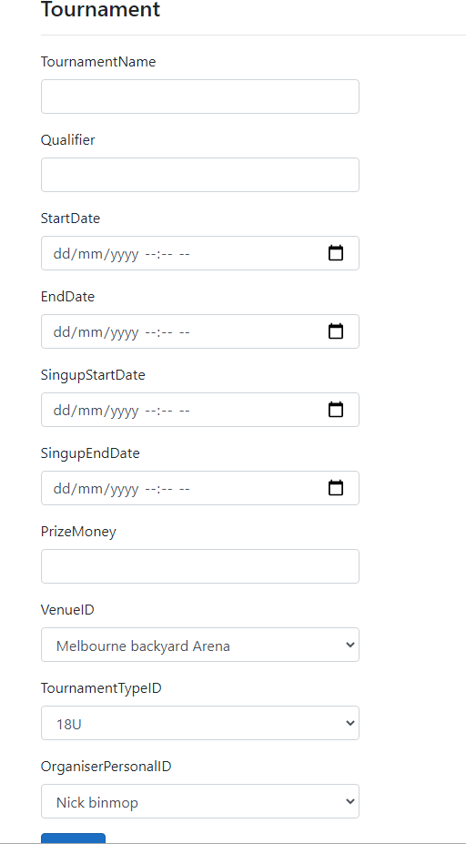

While the following images showcase the details and edit screen of the database.

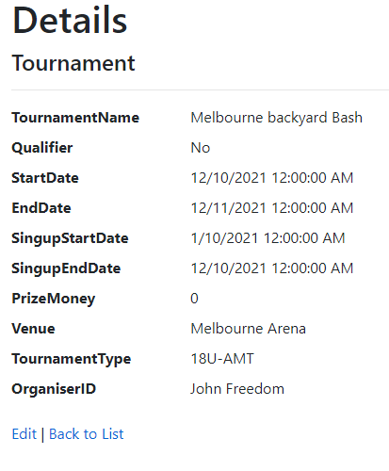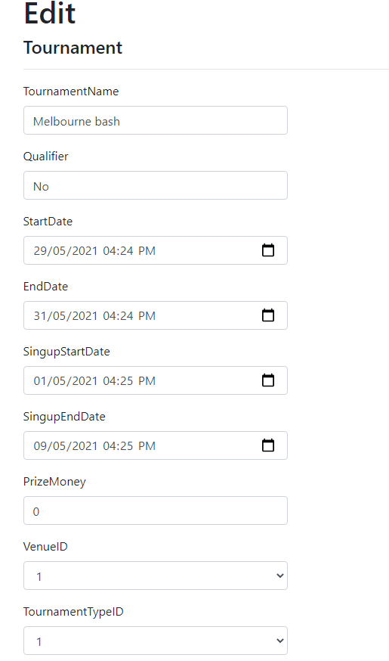

**Tournament Bracket**

This section of the database serves as a list of the different brackets that can be found in a tournament, therefore the table will record the tournament, the age brackets and the rating of the tournament to make up this database, unlike the other database this one consist only of pre-selection when making an entry, hence the user will only have to select an option from a drop down for this table as seen in the second image.

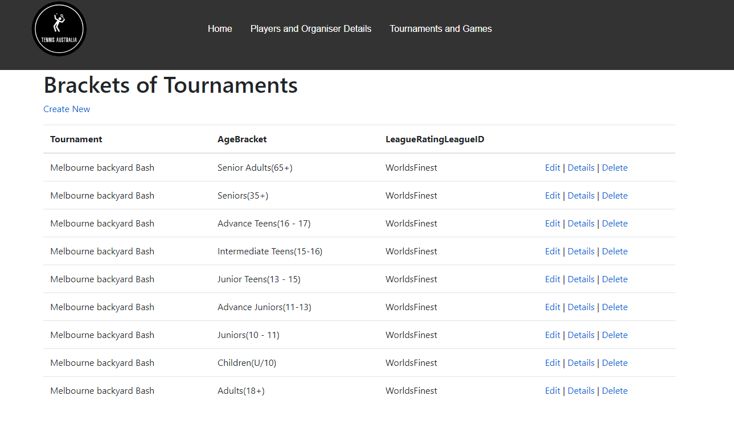

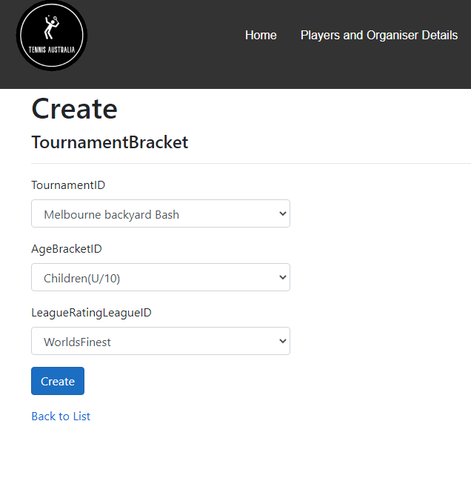

While the following images showcase the details and edit section of the database.

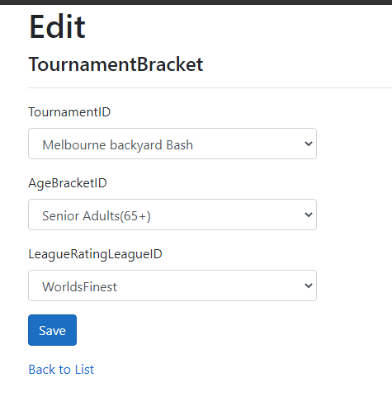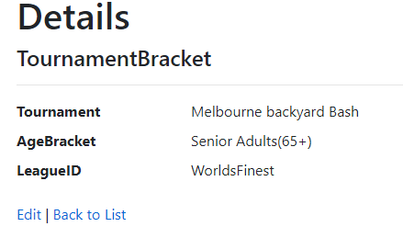

**Matches**

The matches database stores all the games played for a tournament and the players of the tournament and the round the match occurs for the tournament. However unlike other tables this database will use the registration number instead of the name of the player, if the user would like to access the name the user can click on the number to be taken to the database for players to find the name for the number.

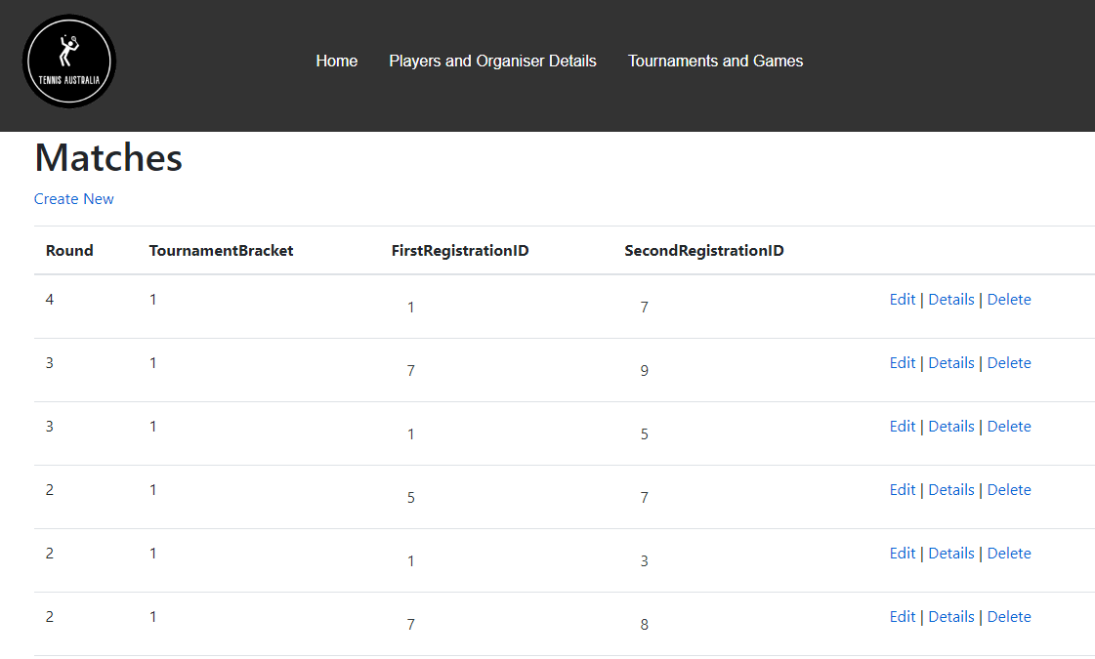

For the creation of entries the create button is under the matches title, while it is important that the user knows the registration number of the player before they put them into a match as the below image is an example of the creation screen which does not contain the name of the players. While the options for edit, details and delete are found on the right hand side of the above image.

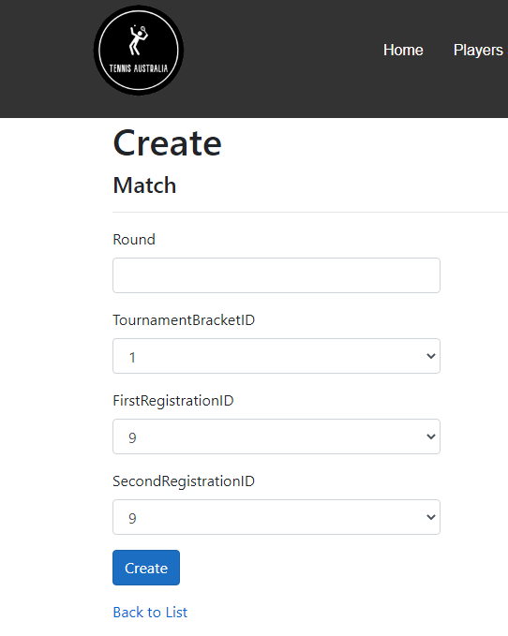

In terms of the details and edit section pages an example can be seen below.

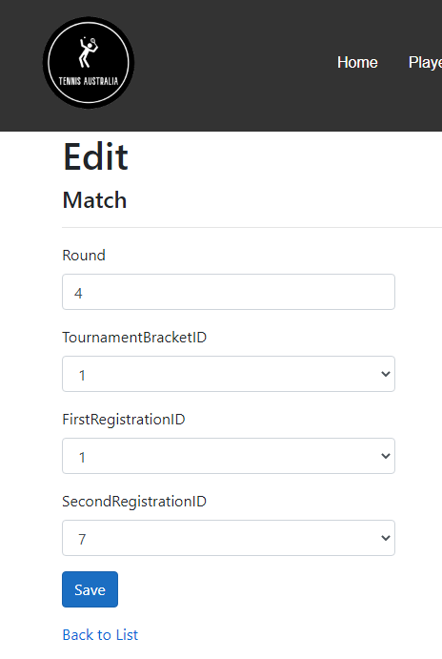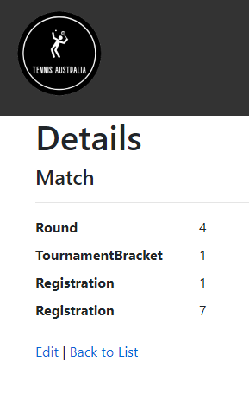

**Set results**

The database of set results is to serve as the database responsible for the individual scores during sets for each player and the associated match that it relates to, like the match table the user needs to know the ID of the match before they assign it to this table. As such when filling out this table the user needs to establish the set they are recording the score for, the score for that player based on their position in the match table so if registration ID score for the first player in set results is 45, that score is then for the first registration ID whose in the Match table and the same for the second registration ID, beside that the match ID is also to be recorded when creating an entry.

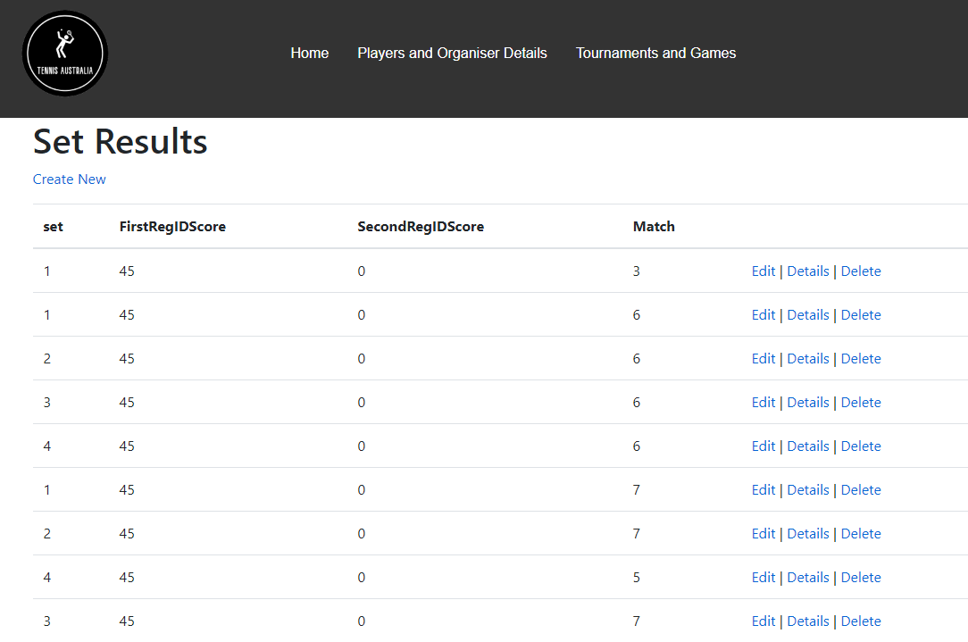

While for the creation button it is located under the title while the options for edit, details and deletion of an entry can be found on the right hand side as shown in the image above. An example of edit and details can be found below.

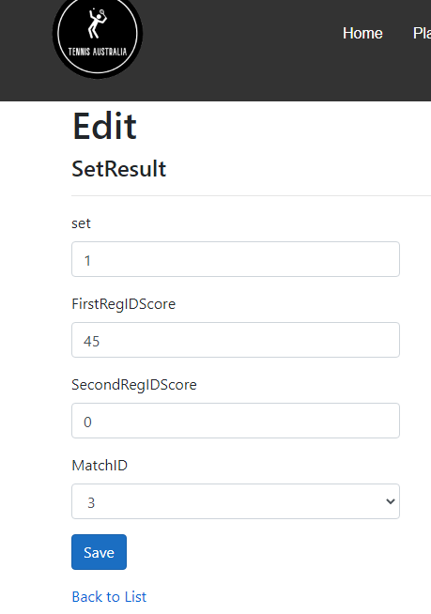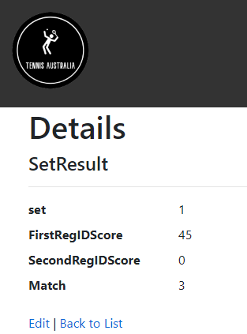

**Finale results**

The final results database, much like the set results table, is to register the match being recorded, the registration ID of the winning player and their overall sets won, then the second players registration ID and their overall sets won, then finally the overall sets played for the match as shown in the below image.

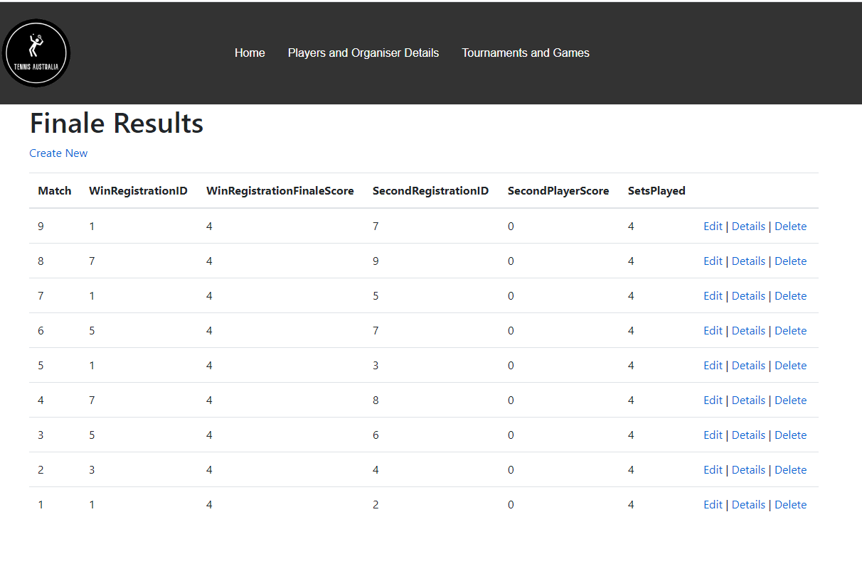

In terms of creation of an entry, the create button can be found under the title of the section while the edit, details and deletion of an entry can be found on the right hand side with examples of these screens shown below.

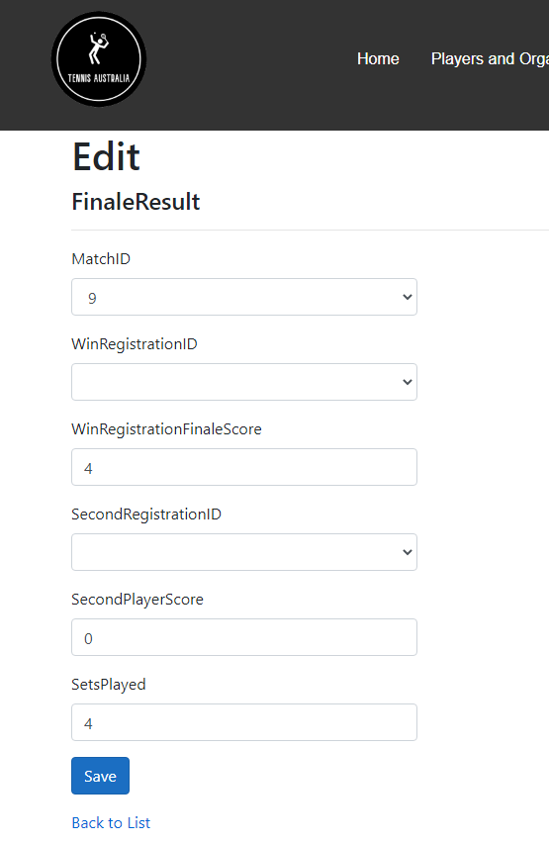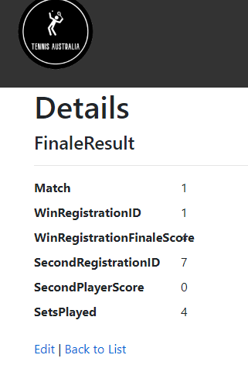

**Deletion**

Regardless of the database table all the databases share the same delete page layout and design as can be seen in the following image the user is presented with the option to delete an entry with ease by clicking the delete button.

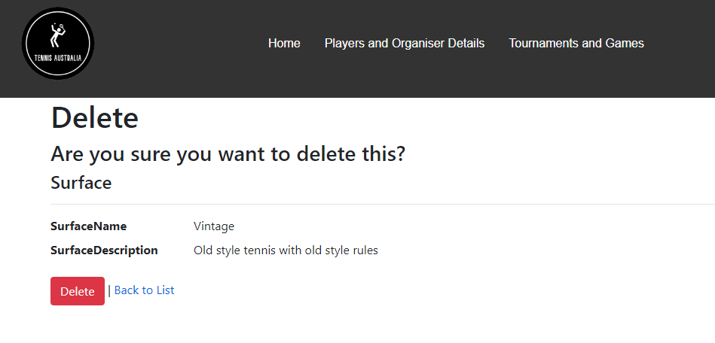

**Edit**

While every section has an edit option for all edit options to be saved once the user is on the item they want to edit, at the button of the edit page is a blue button with the word save which once pressed will save the entry for the user and take them back to the index page of the database they are on, as the below image is an example of what the button looks like.

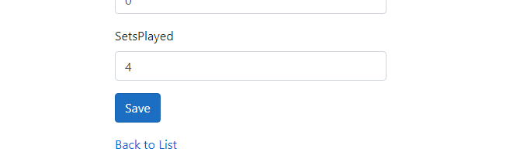

**ERD**

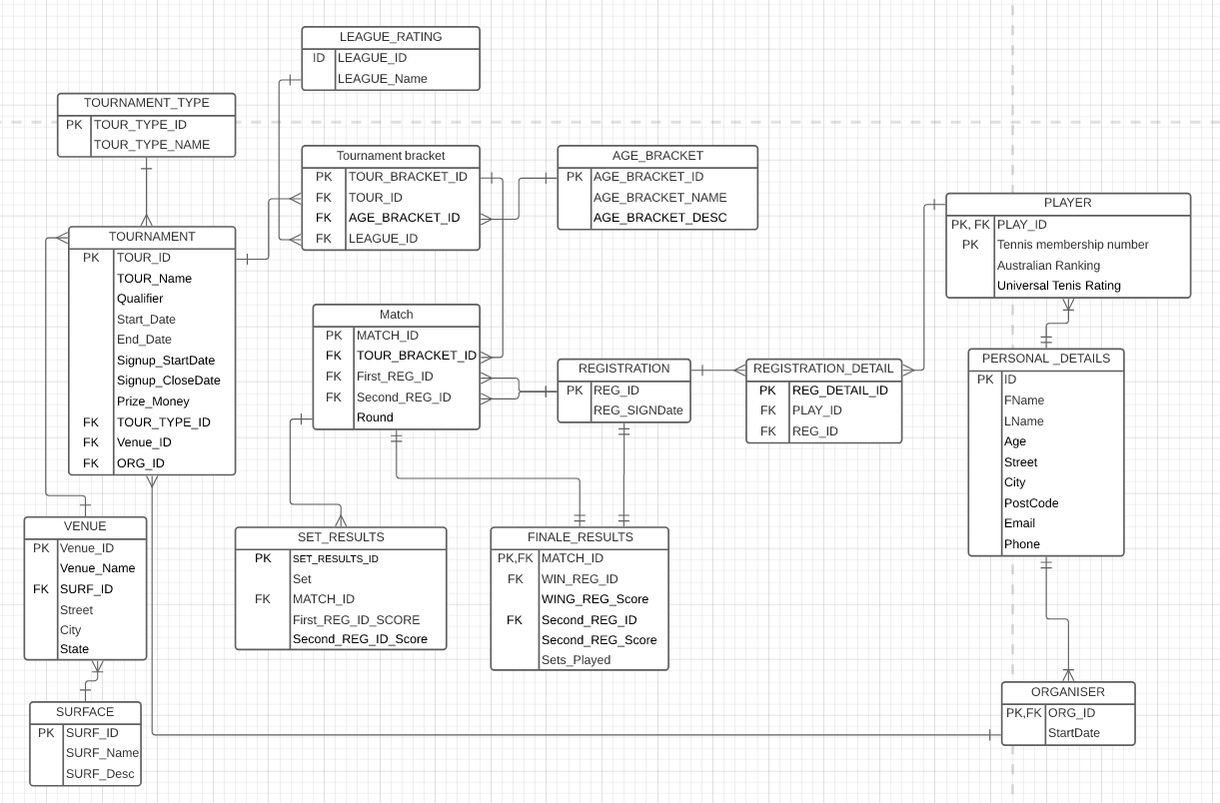

The following ERD design was chosen to best reflect the real world example of what is required to manage the tournaments and the associated players, organisers and games. With the ERD covering all associated topics that can be found when navigating the Australian tennis website to best capture the management system required for this project ("Tournaments | Tennis Australia", 2021). Therefore the current ERD is the best model for the application with some tables that after reviewing were found to be crucial such as the registration details, as it can not be brought into the player table because a player can have many IDs and the IDs can belong to a lot of players due to duo IDs and singles. While for results the set results and final results capture two different parts of the matches with one being a more in depth review of a match and the other just a general outcome. The tournament bracket is required as well because a tournament will have many different leagues and age brackets per one tournament so this captures this area. Beyond these aforementioned tables the rest are just necessary in order to properly capture the required details for the application and removing them would mean the application can not carry out the desired purpose.

**Test Cases and Results**

**Players**

**Create**

Before:

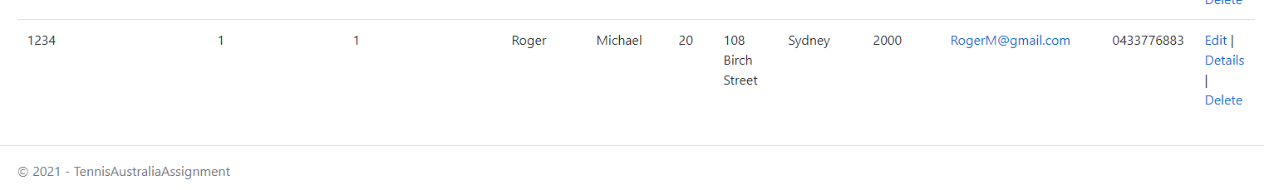

After:

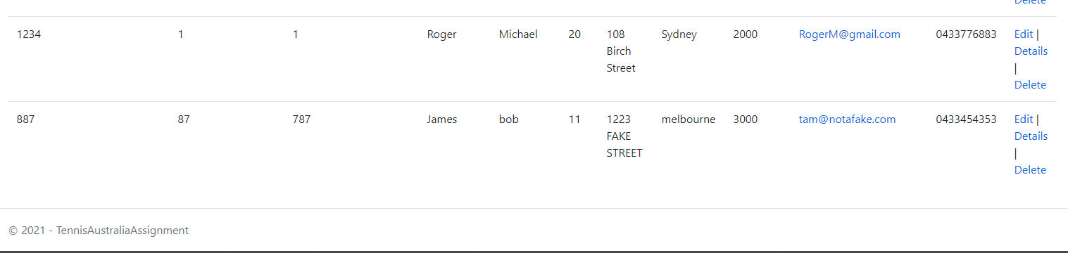

Before:



After:

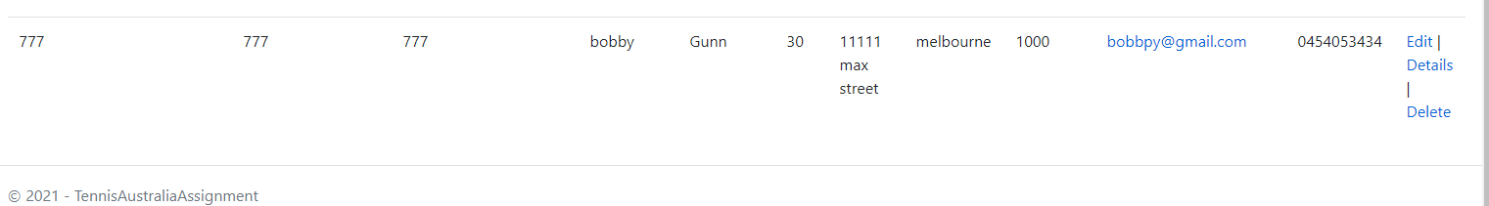

**Edit**

Before:

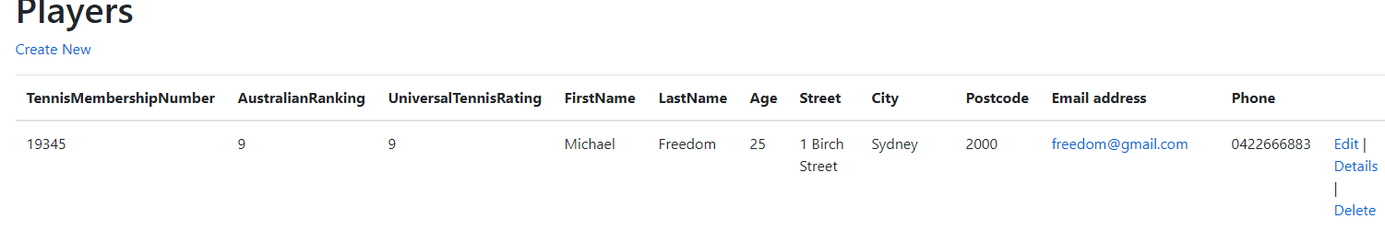

After:

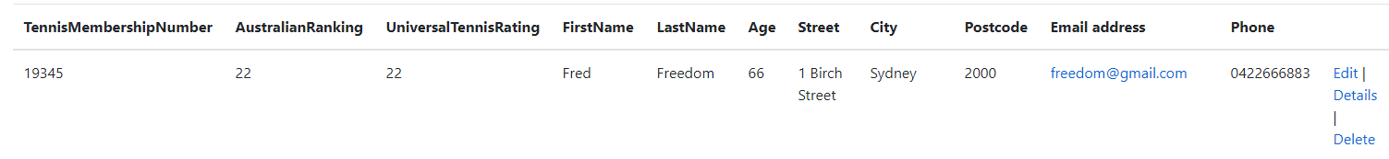

Before:



After:

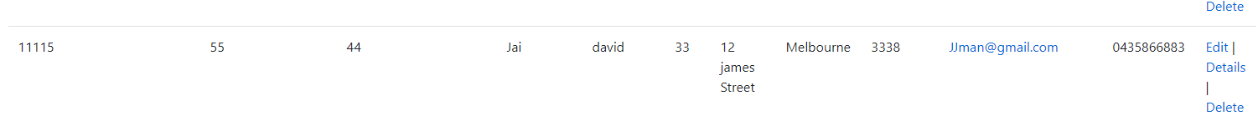

Delete

Before:

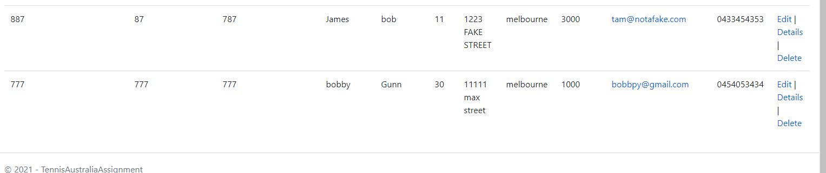

After:

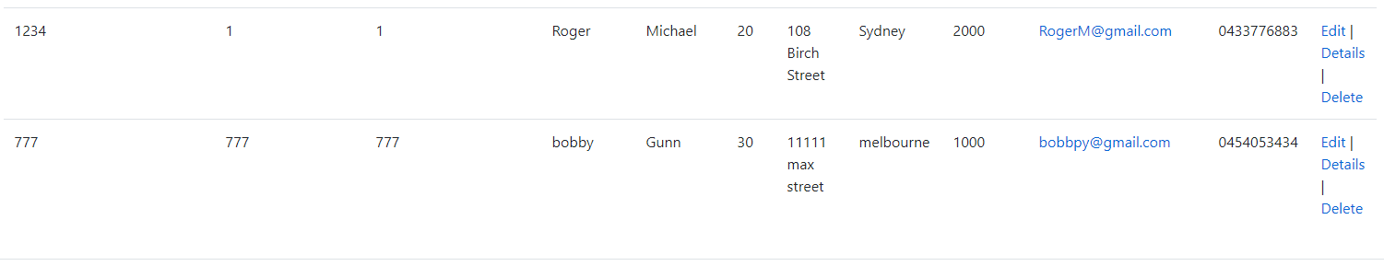

Before:

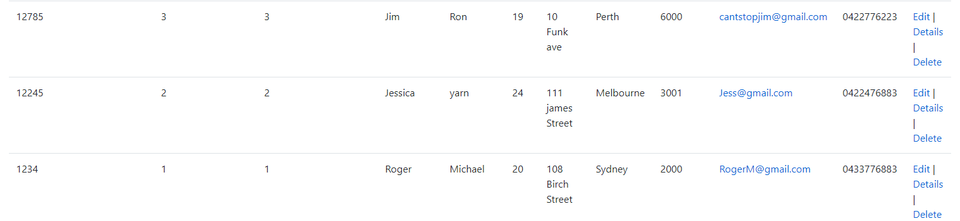

After:

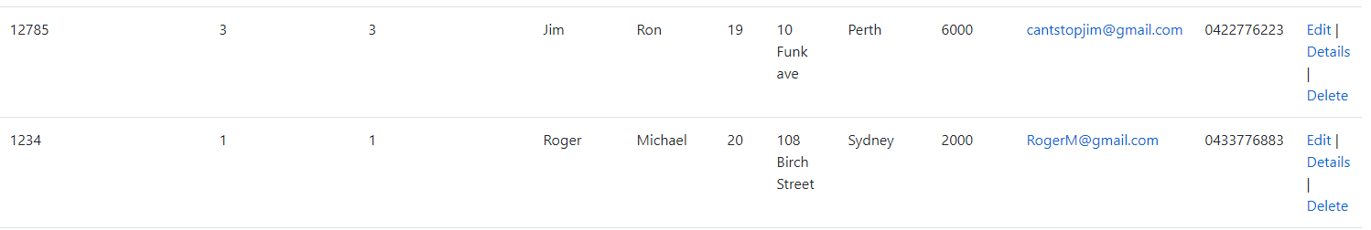

**Validation**

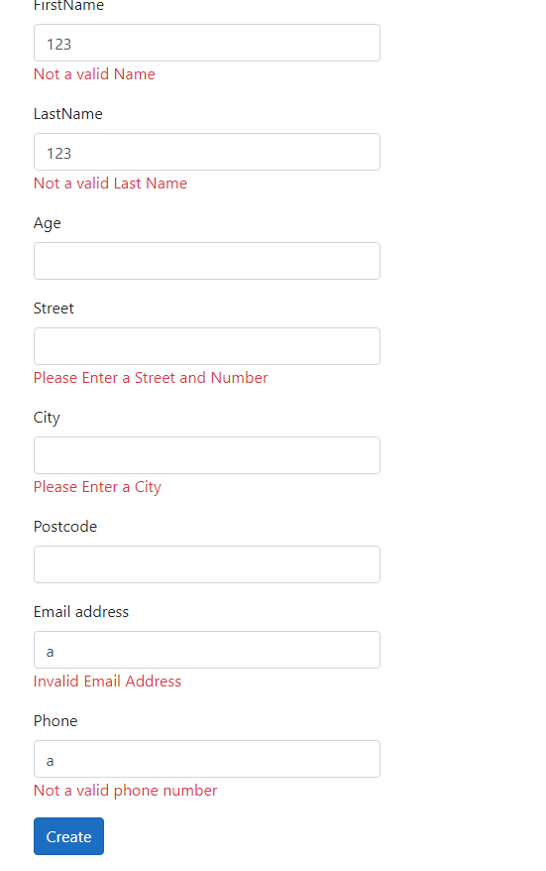

**Organiser**

**Create**

Before:

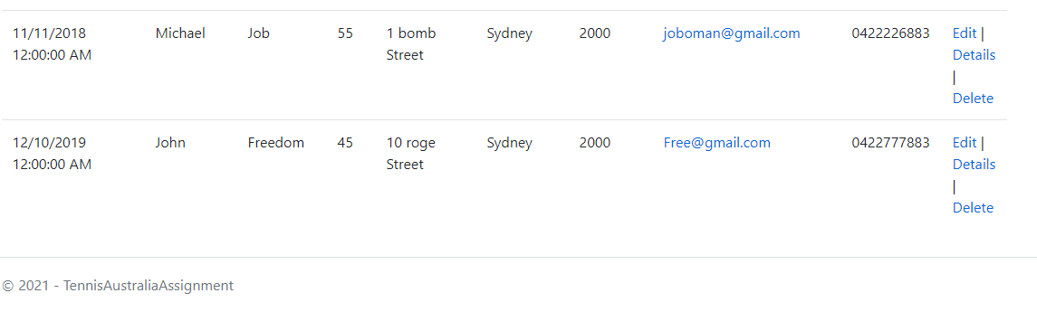

After:

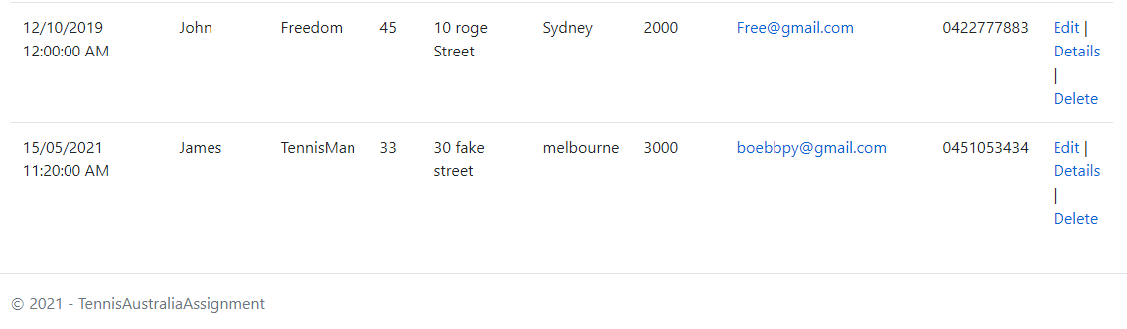

Before:



After:

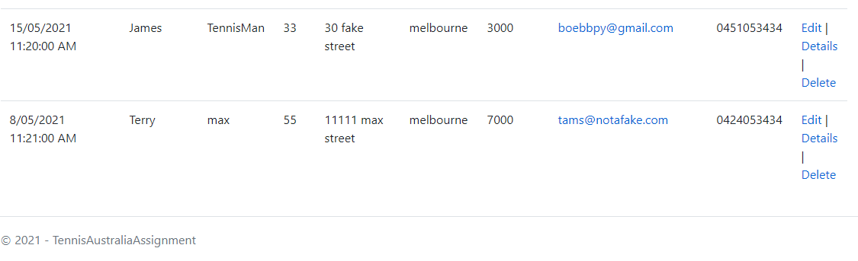

**Edit**

Before:

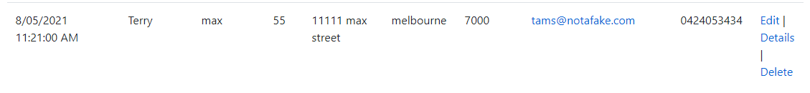

After:

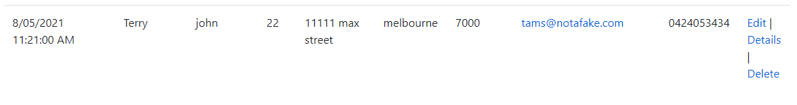

Before:



After:

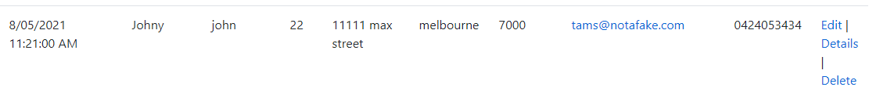

Delete

Before:

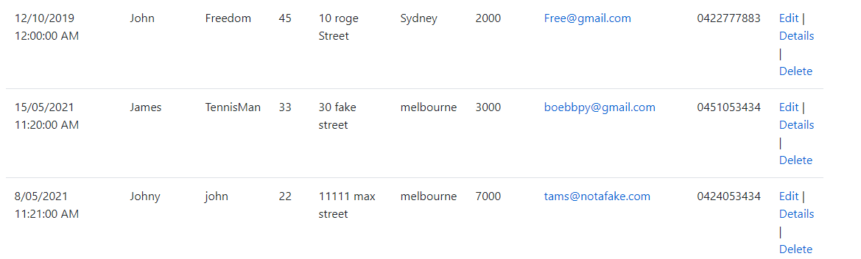

After:

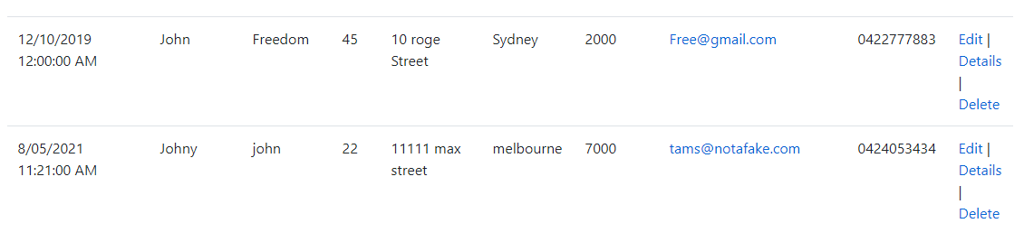

Before:

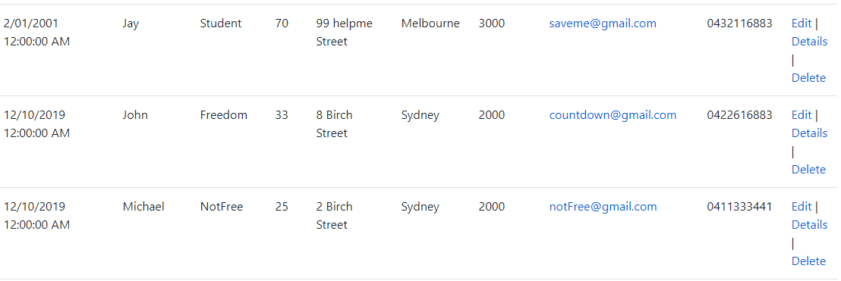

After:

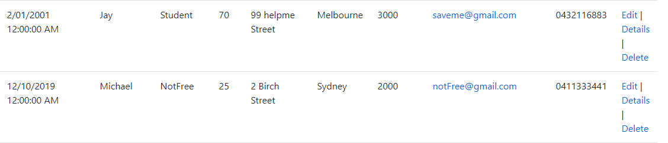

**Validation**

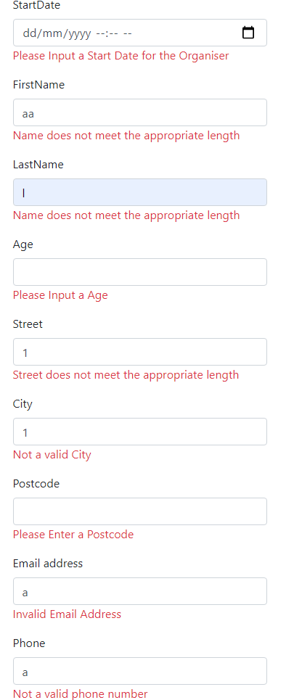

Registrations

**Create**

Before:



After:

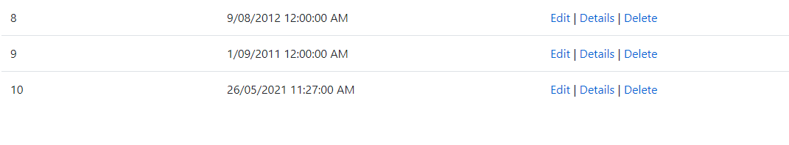

Before:



After:

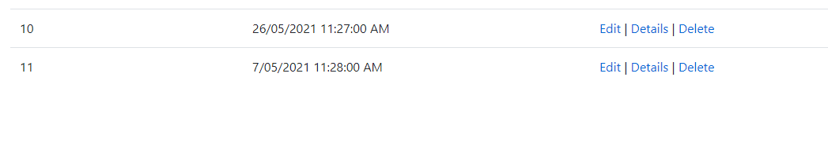

**Edit**

Before:



After:



Before:



After:



**Delete**

Before:

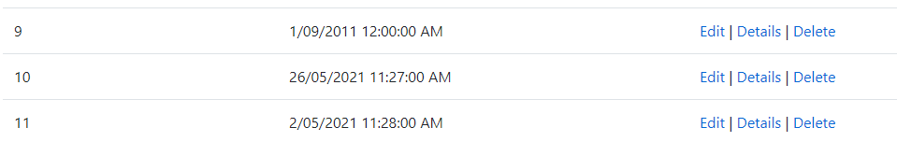

After:



Before:

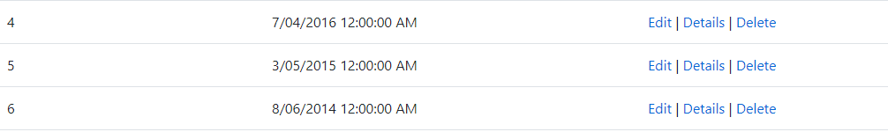

After:

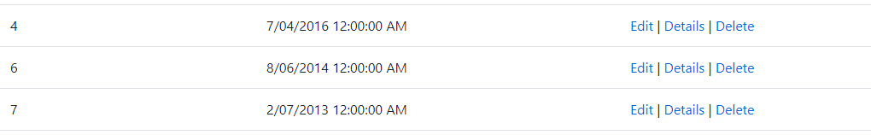

**Validation**

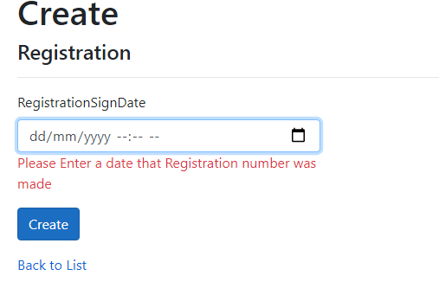

**Registration Details**

**Create**

Before:

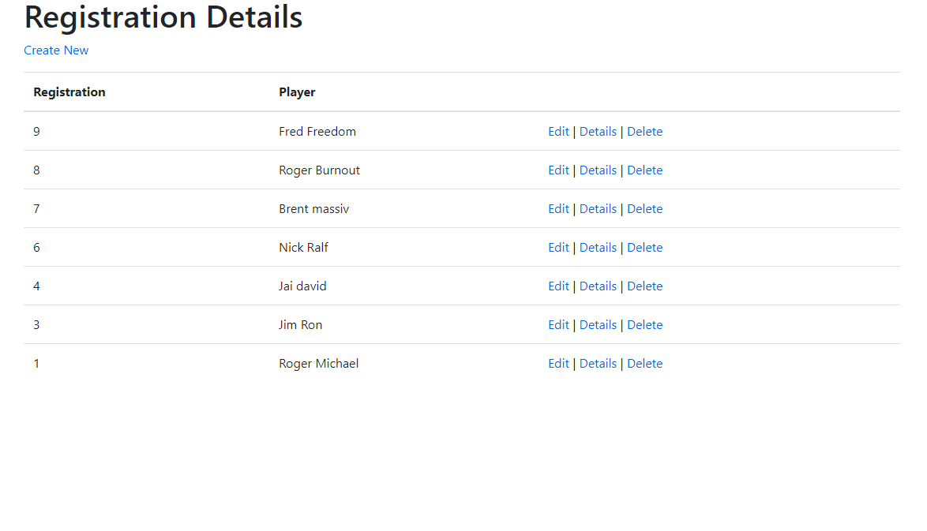

After:

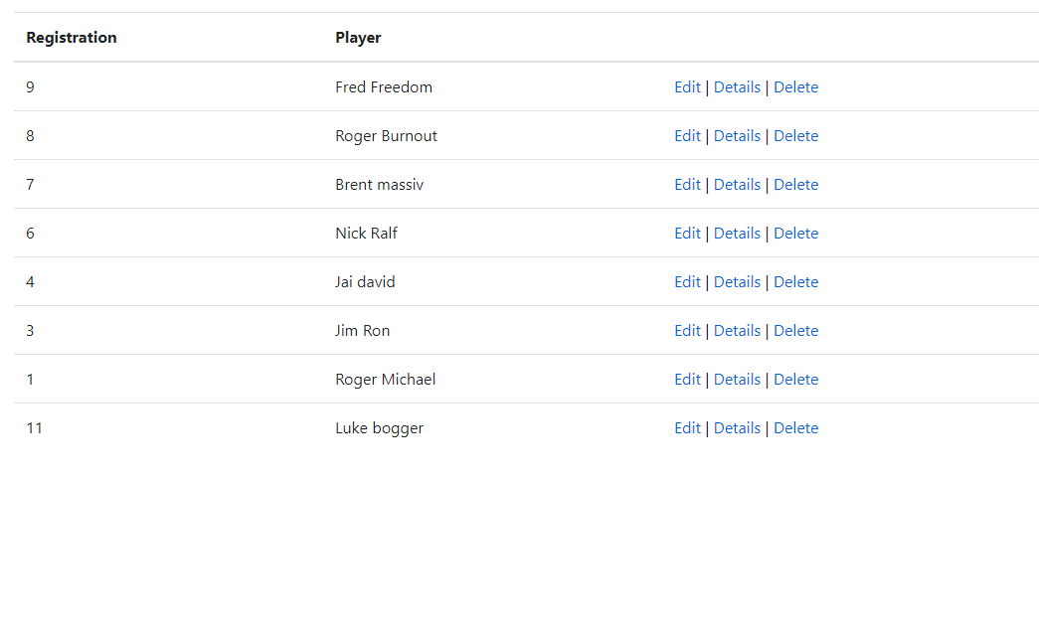

Before:



After:

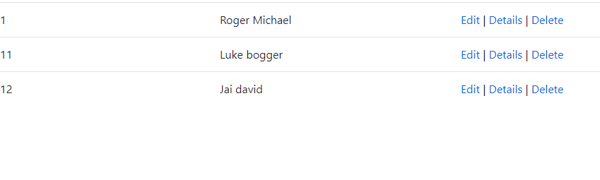

**Edit**

Before:



After:

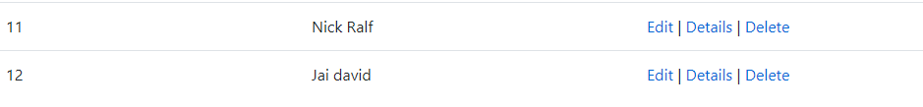

Before:



After:



Delete

Before:

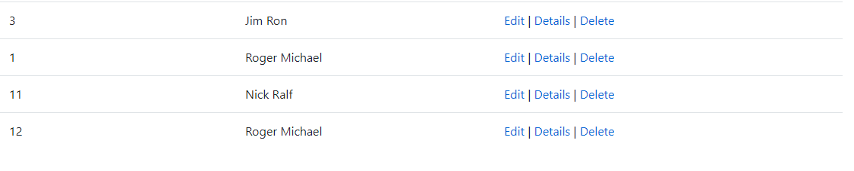

After:

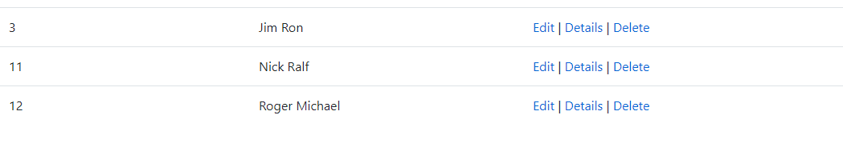

Before:



After:



**Age Bracket**

**Create**

Before:

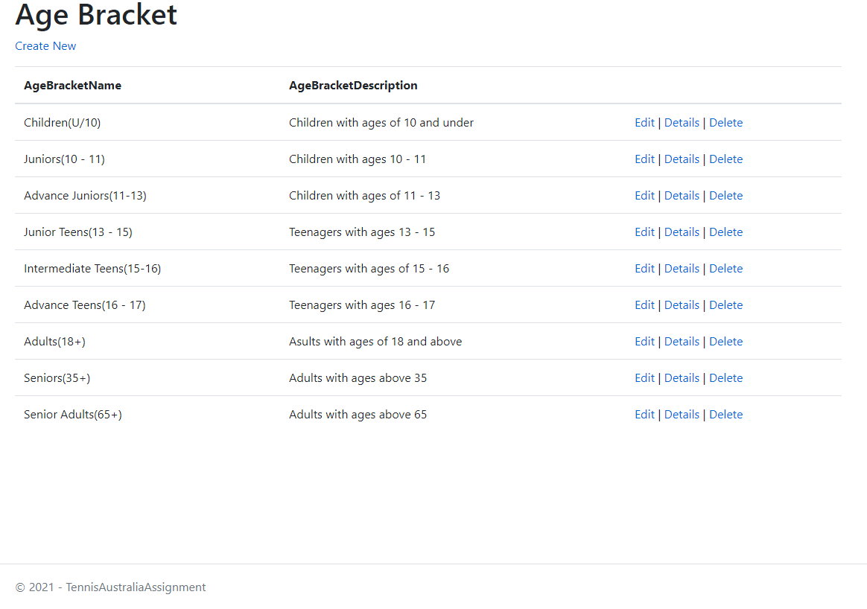

After:

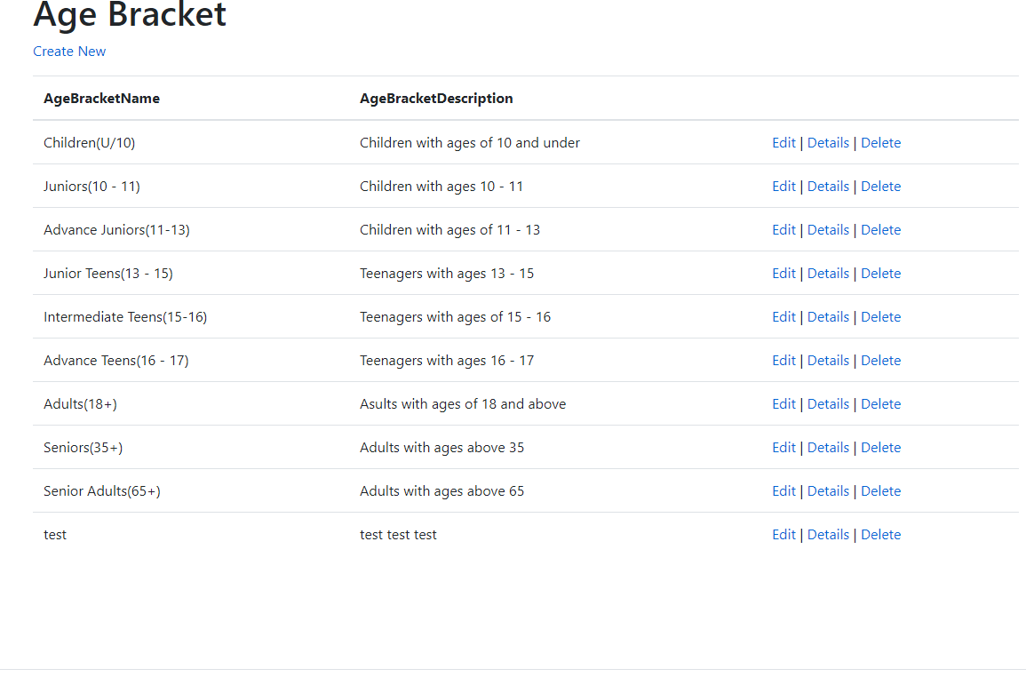

Before:



After:

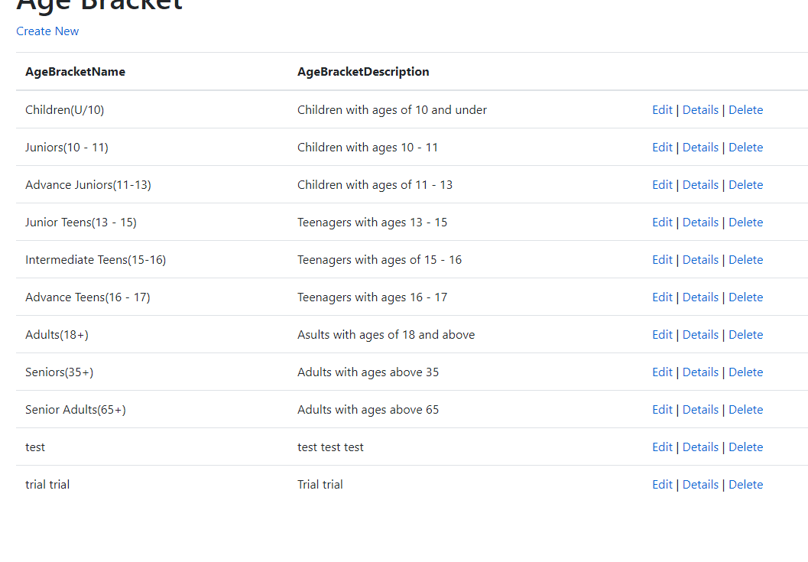

**Edit**

Before:

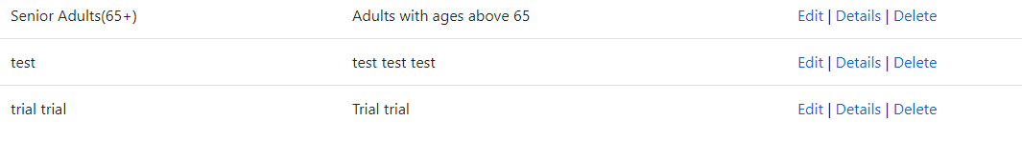

After:

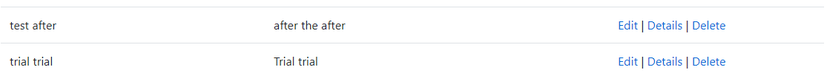

Before:



After:



Delete

Before:

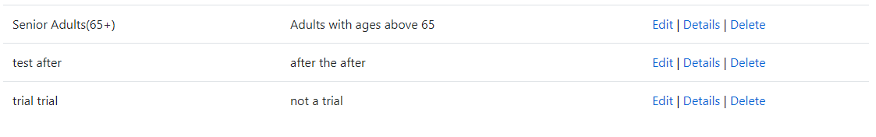

After:

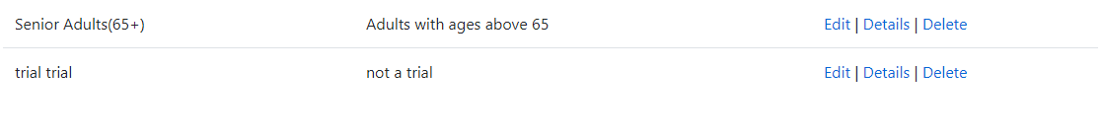

Before:



After:

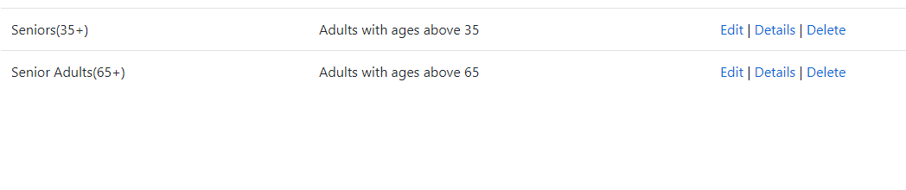

**Validation**

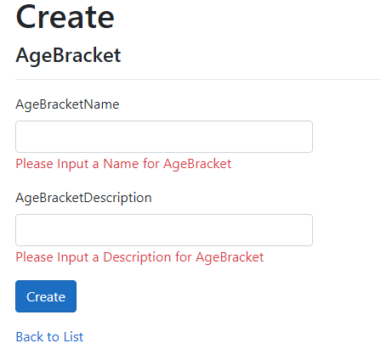

**Tournament Type**

**Create**

Before:

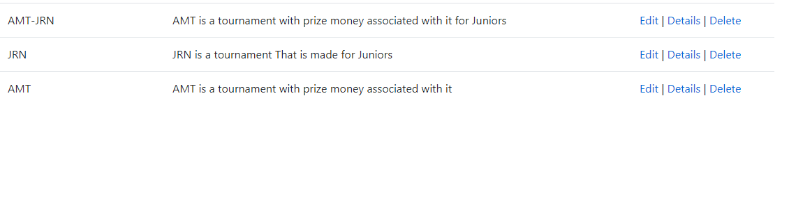

After:

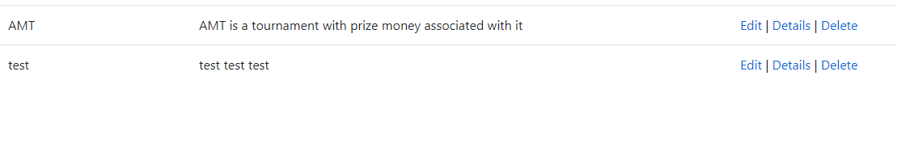

Before:



After:

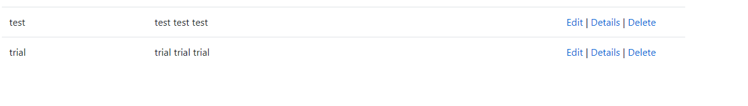

**Edit**

Before:

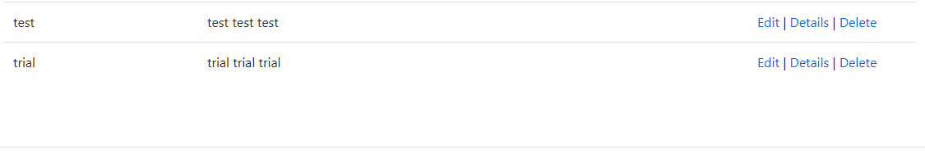

After:



Before:



After:

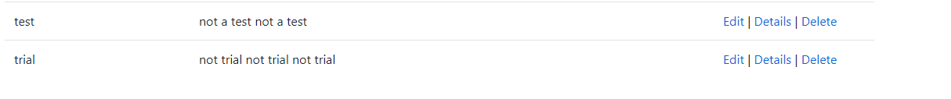

Delete

Before:

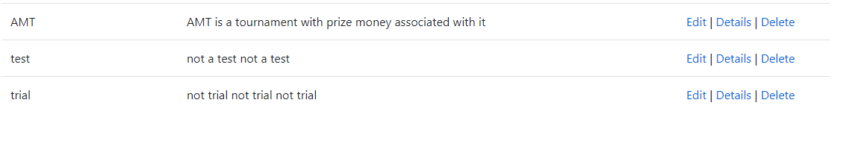

After:

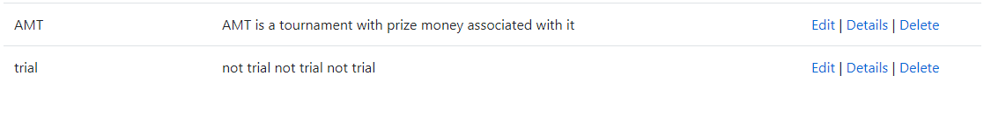

Before:



After:



**Validation**

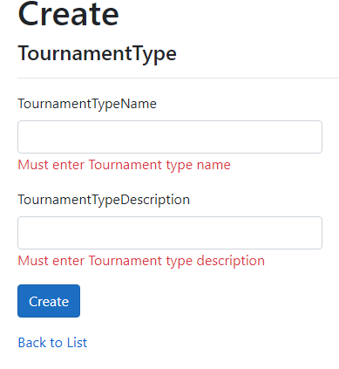

**League Ratings**

**Create**

Before:

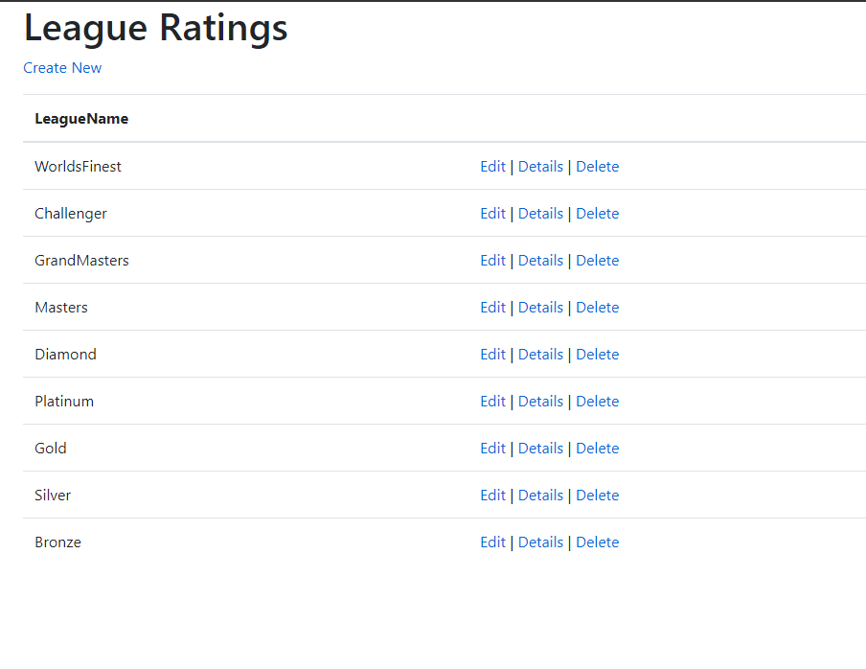

After:

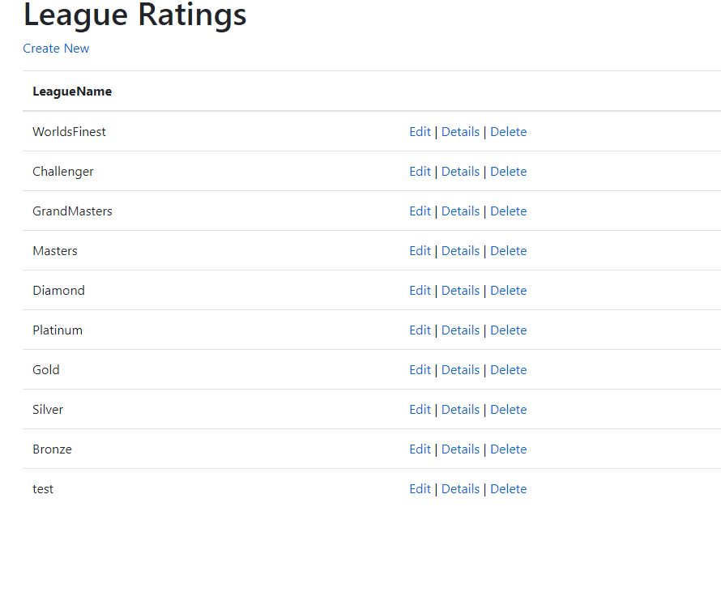

Before:



After:

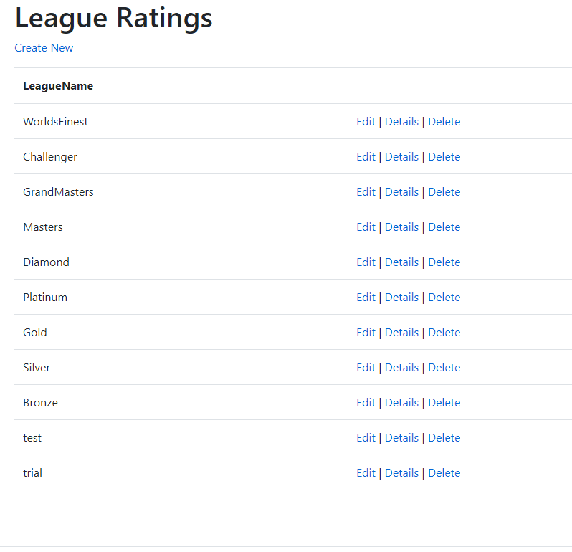

**Edit**

Before:

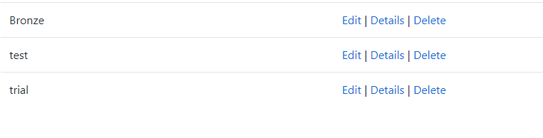

After:

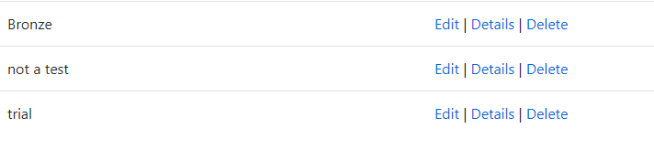

Before:



After:

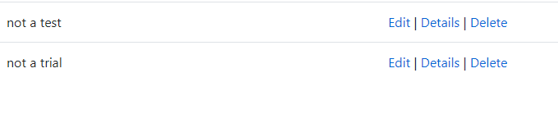

**Delete**

Before:

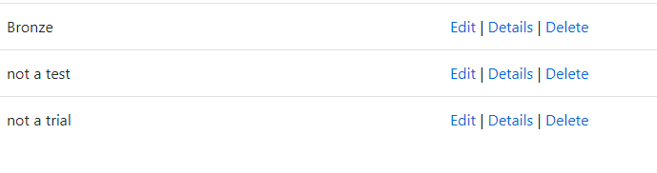

After:

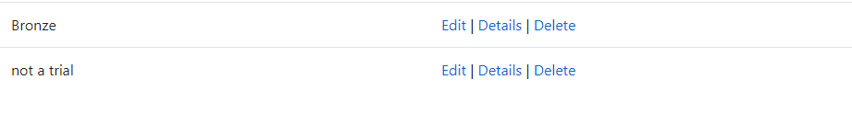

Before:



After:



**Validation**

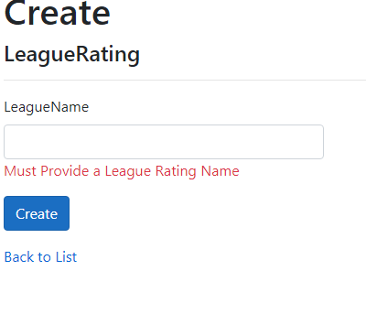

**Surfaces**

**Create**

Before:

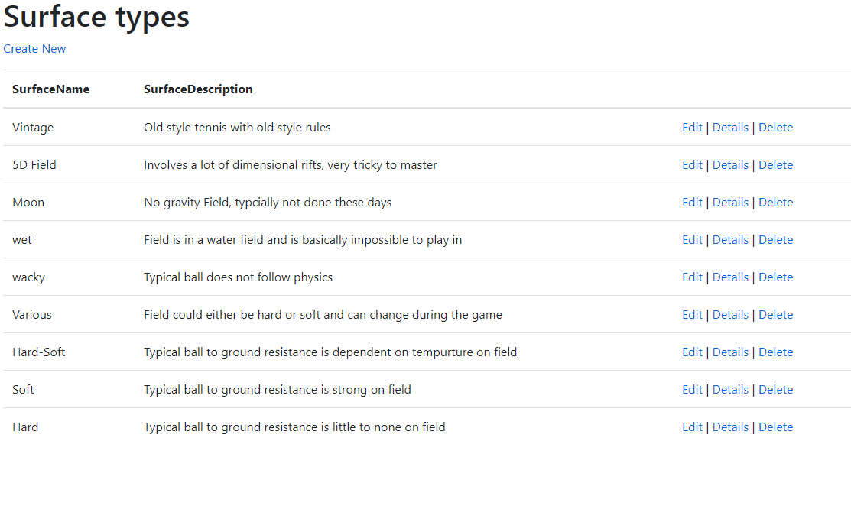

After:

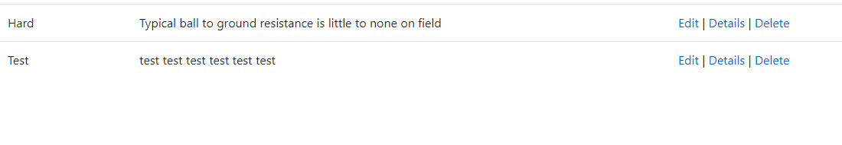

Before:



After:

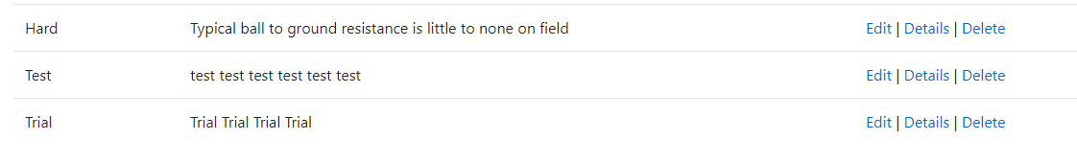

**Edit**

Before:

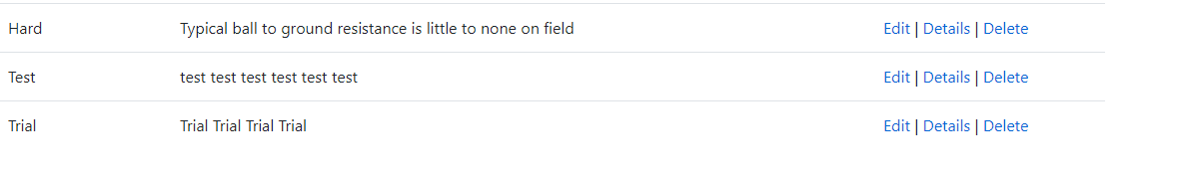

After:

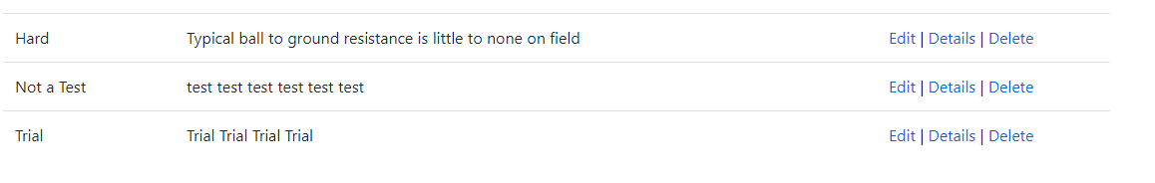

Before:



After:

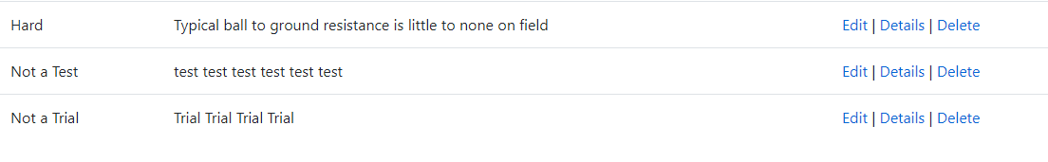

Delete

Before:

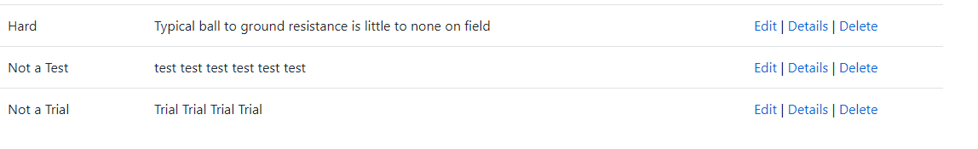

After:



Before:



After:

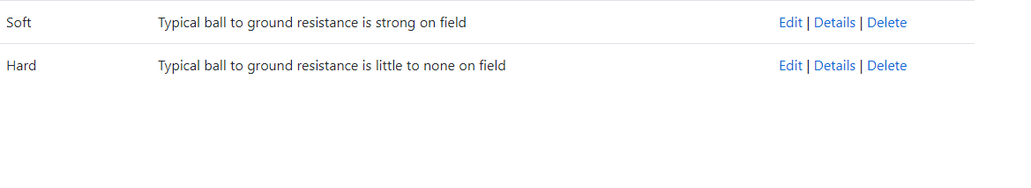

**Validation**

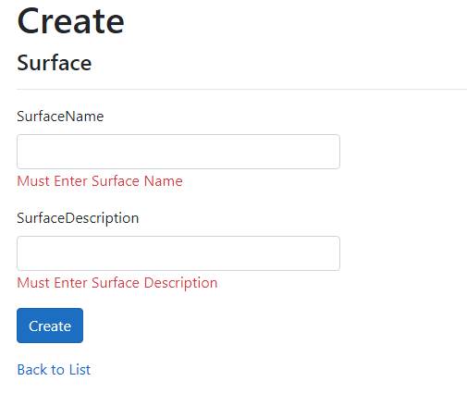

**Venue**

**Create**

Before:

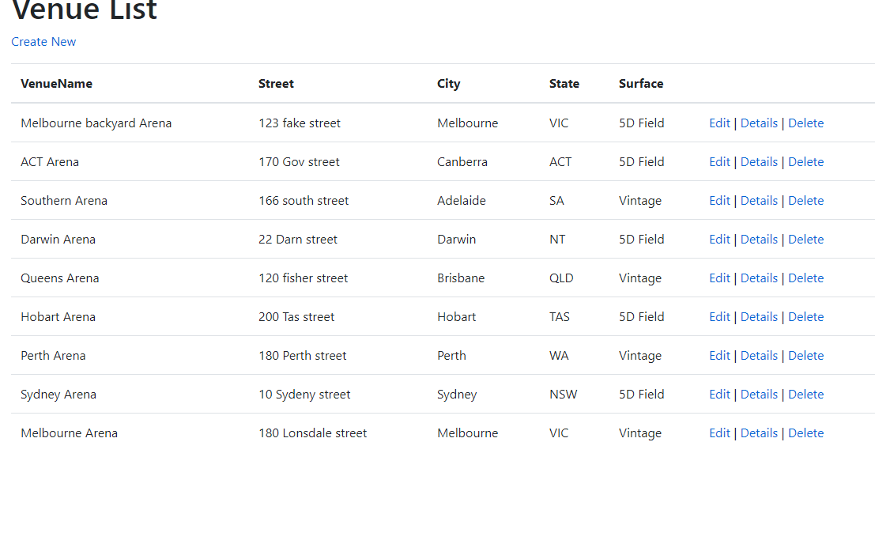

After:

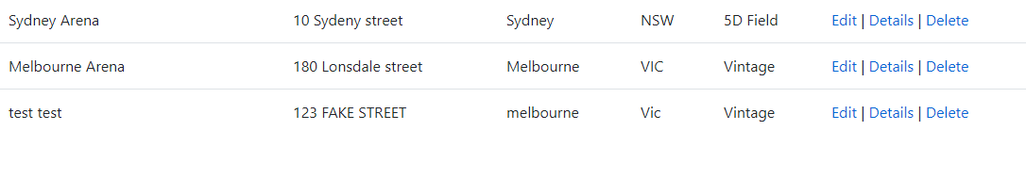

Before:



After:

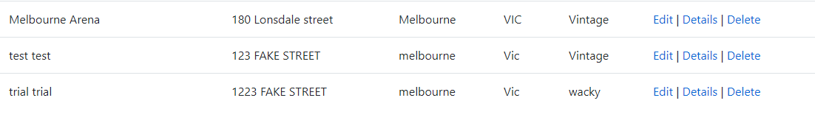

**Edit**

Before:

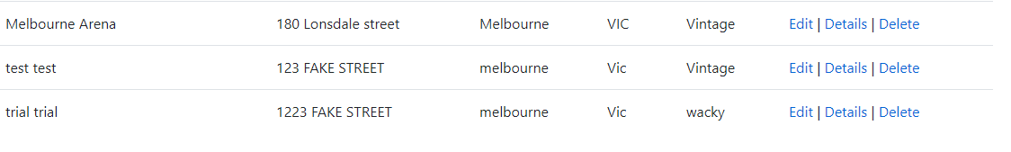

After:

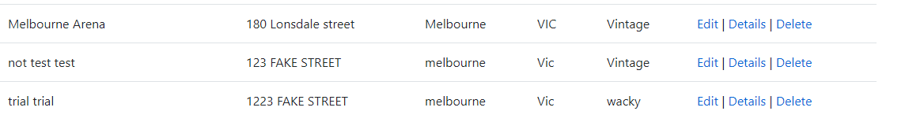

Before:



After:

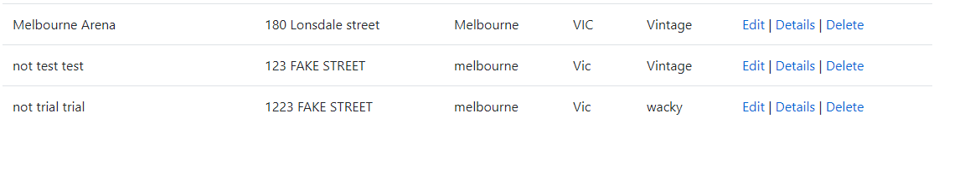

**Delete**

Before:

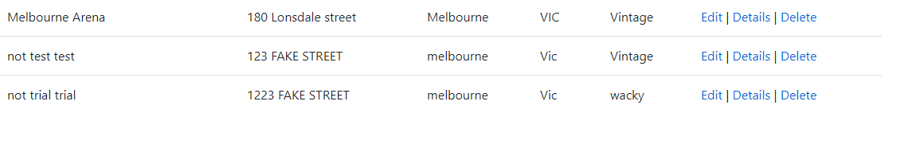

After:

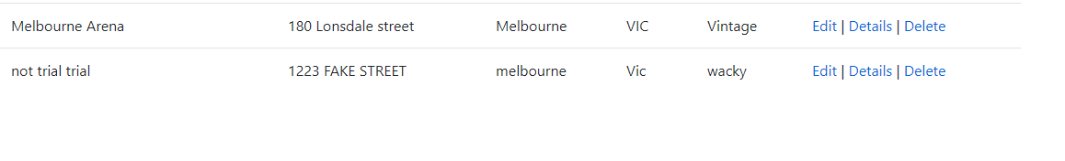

Before:



After:

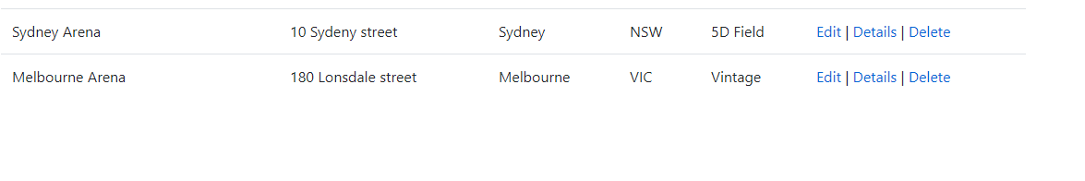

**Validation**

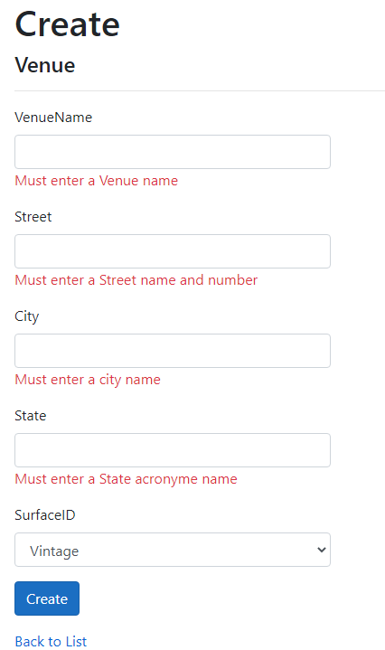

**Tournament**

**Create**

Before:

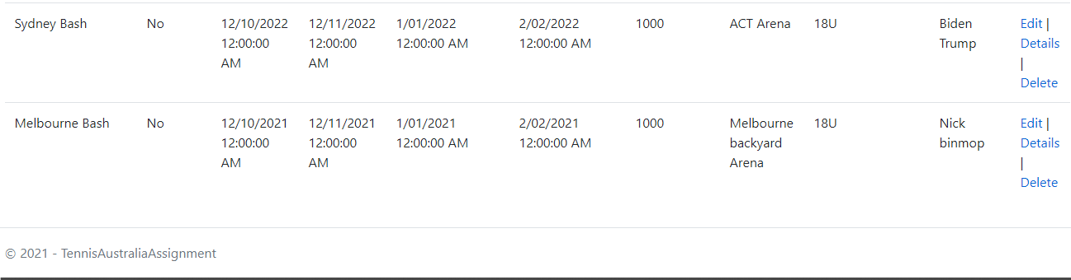

After:

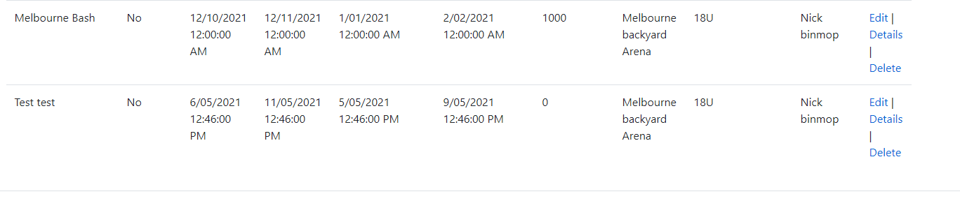

Before:



After:

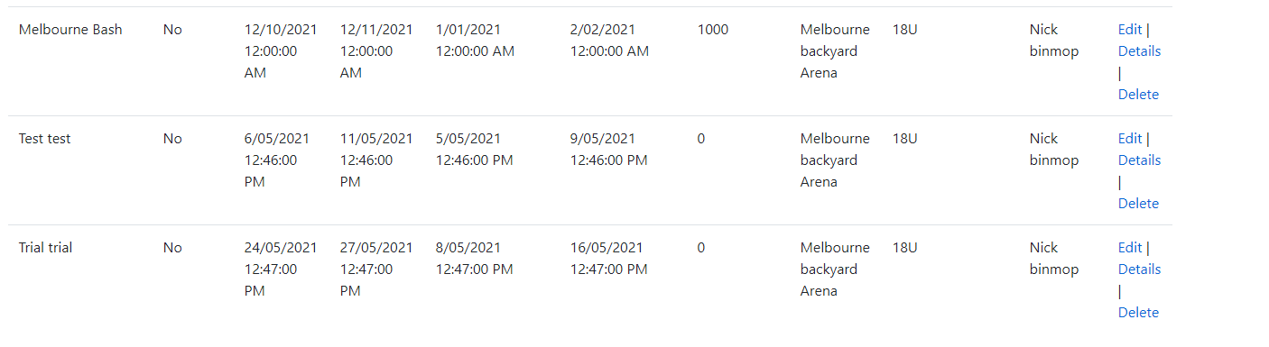

**Edit**

Before:

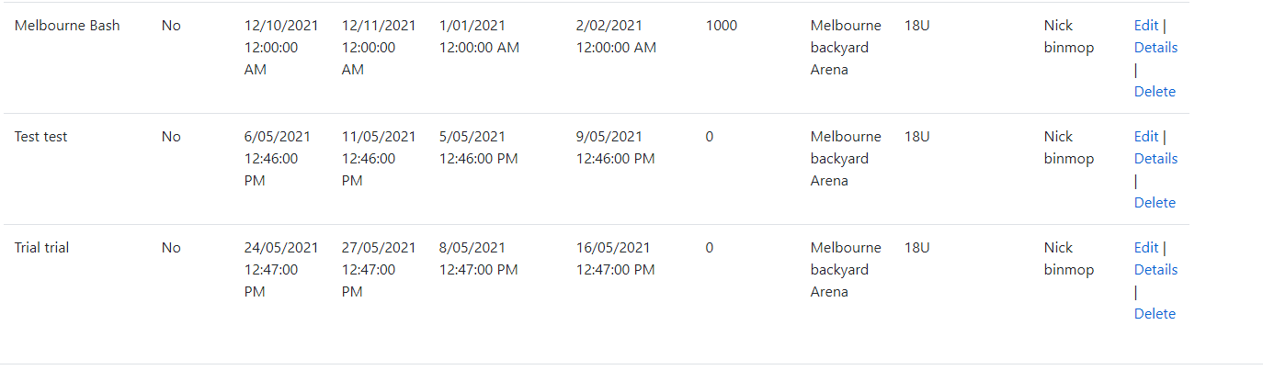

After:

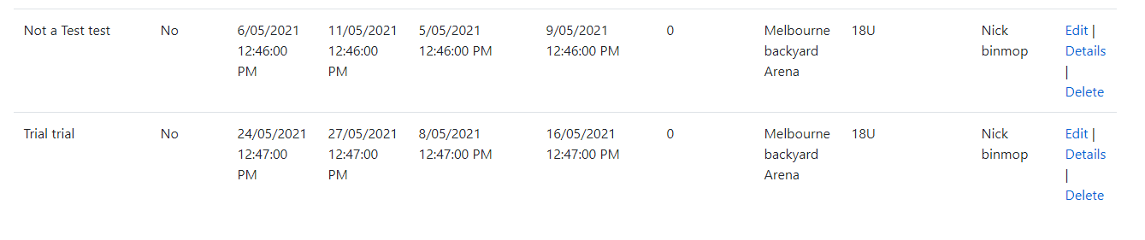

Before:



After:

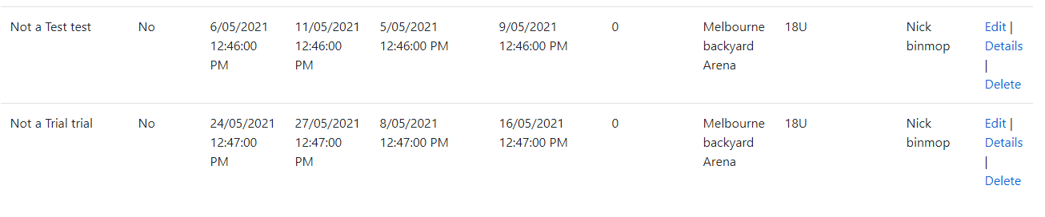

Delete

Before:

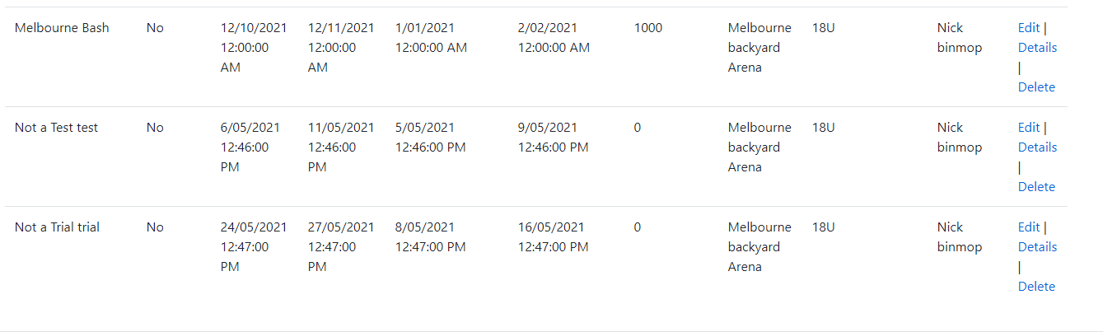

After:

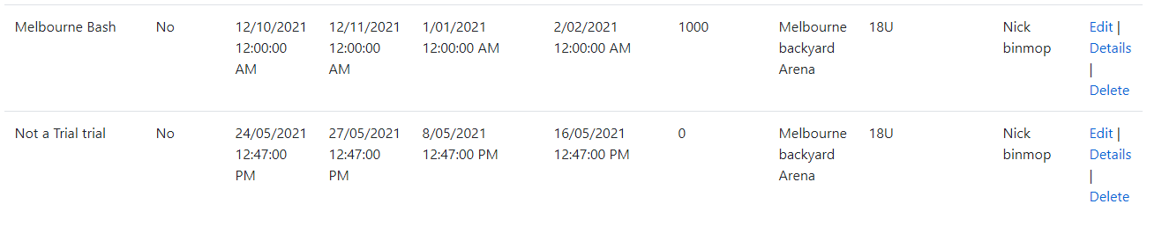

Before:



After:

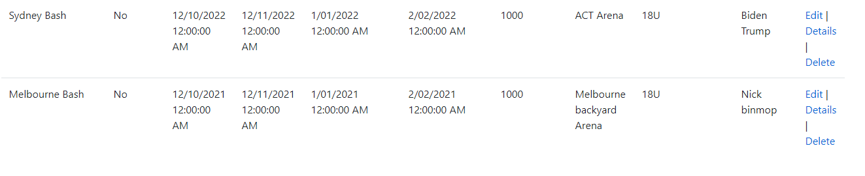

**Validation**

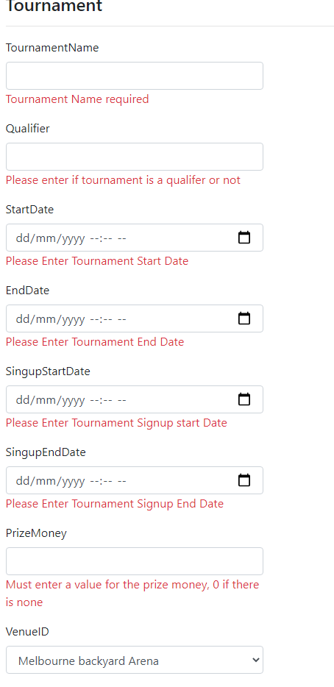

**Tournament Bracket**

**Create**

Before:

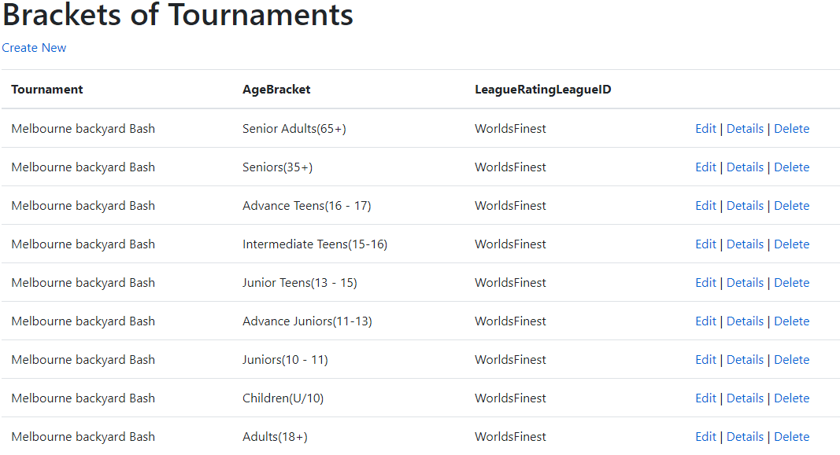

After:

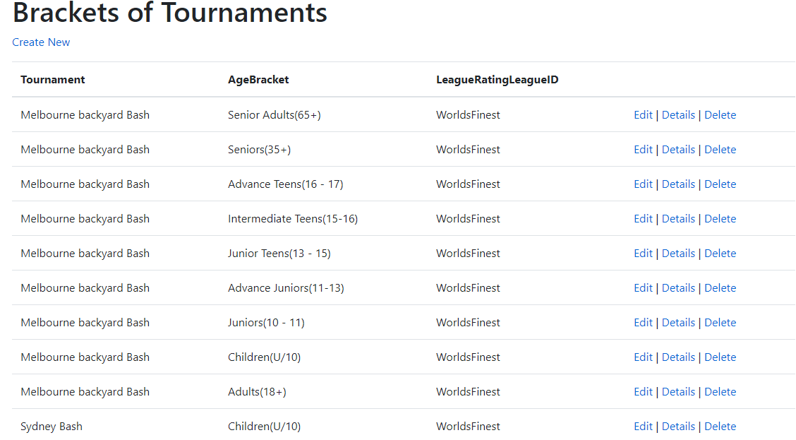

Before:



After:

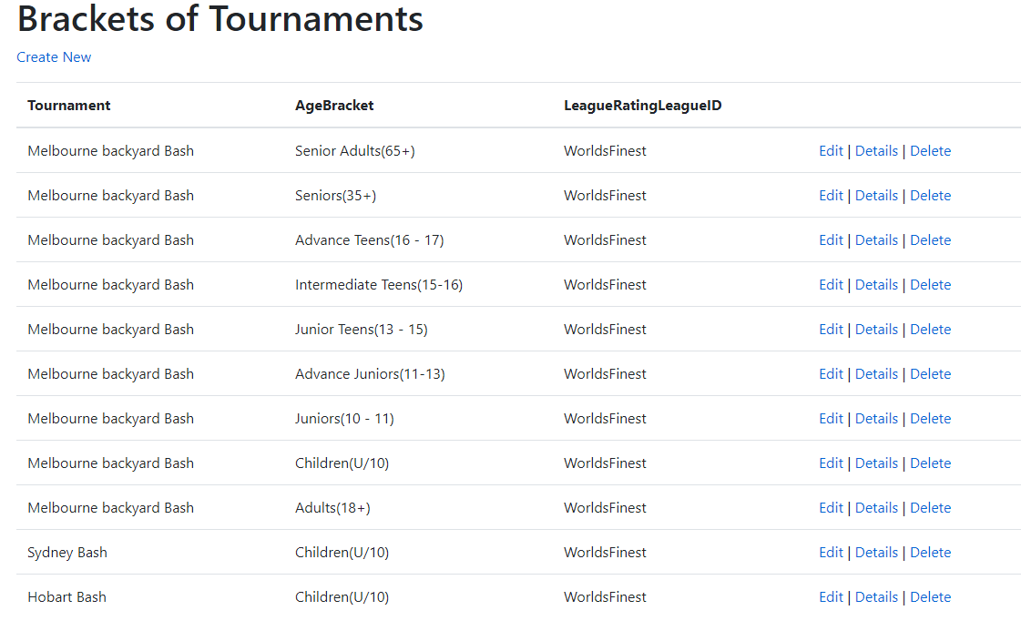

**Edit**

Before:



After:

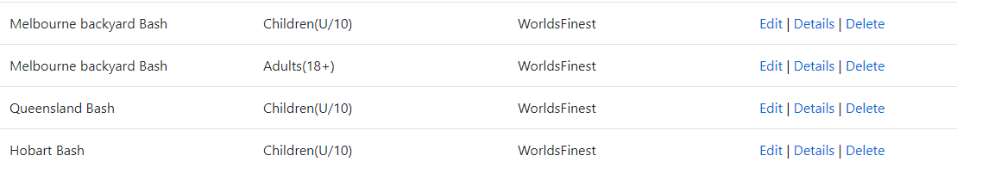

Before:



After:

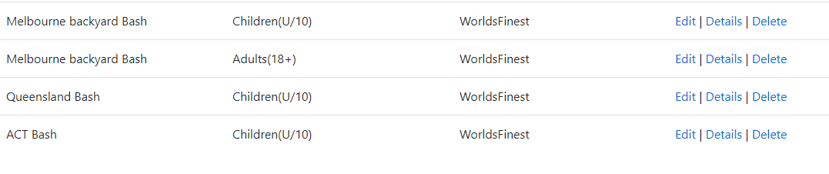

**Delete**

Before:

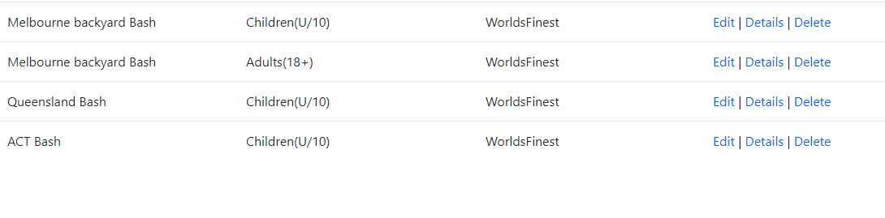

After:

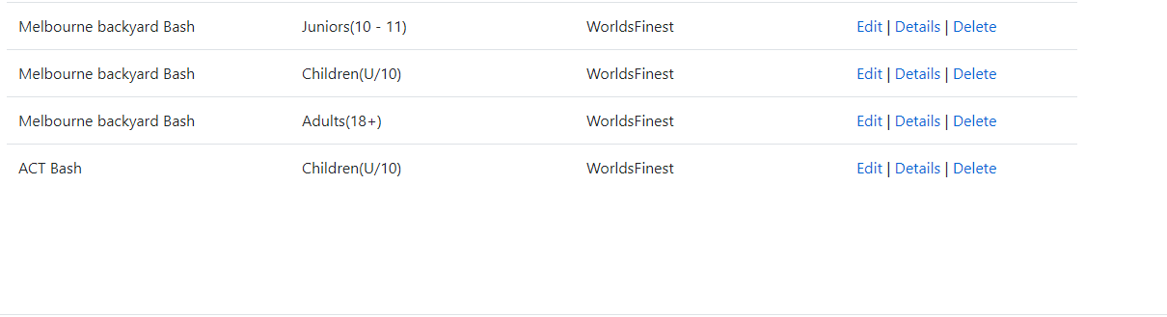

Before:



After:

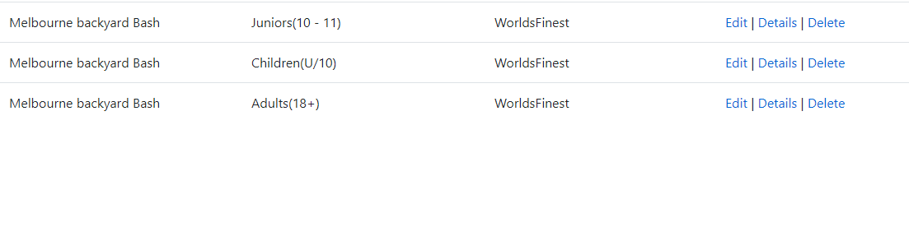

**Matches**

**Create**

Before:

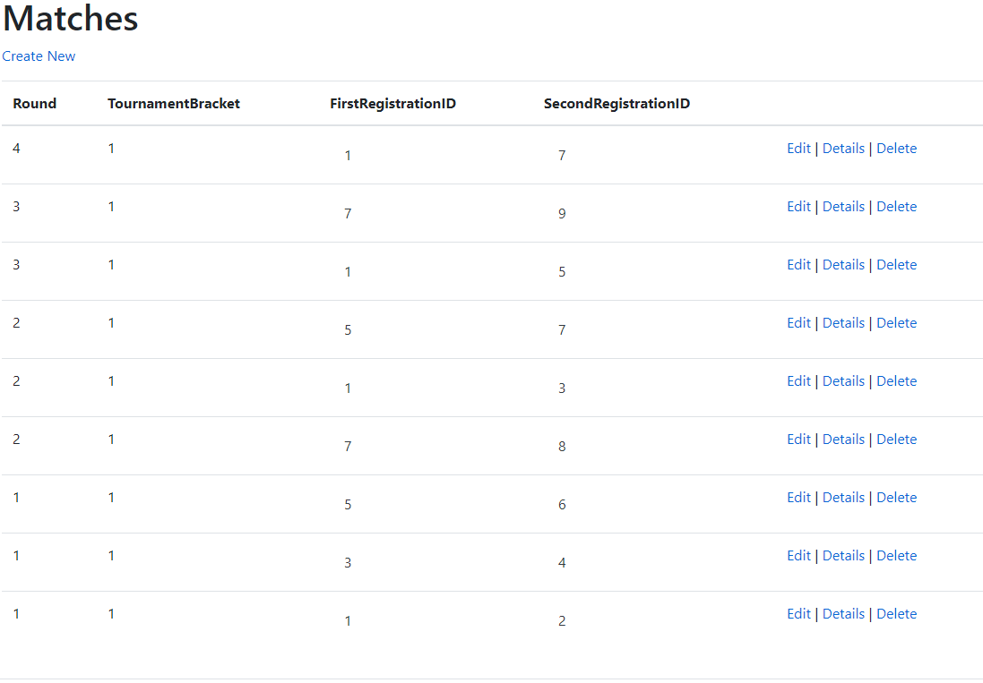

After:

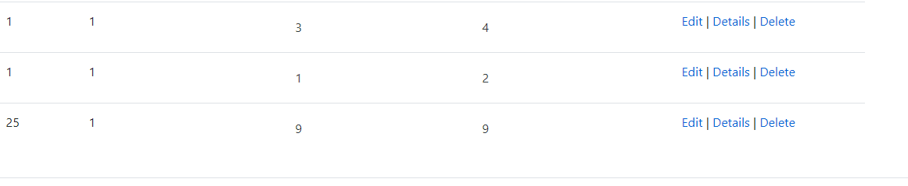

Before:



After:

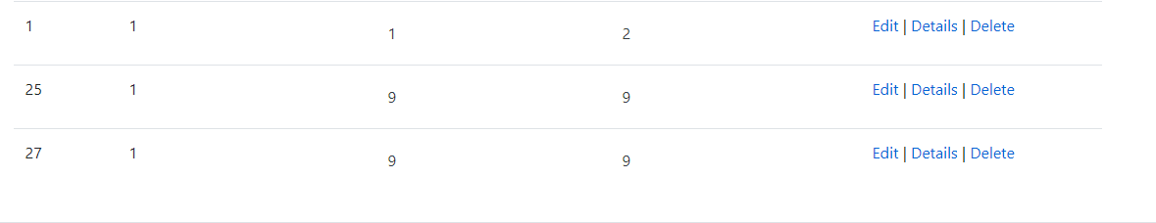

**Edit**

Before:



After:

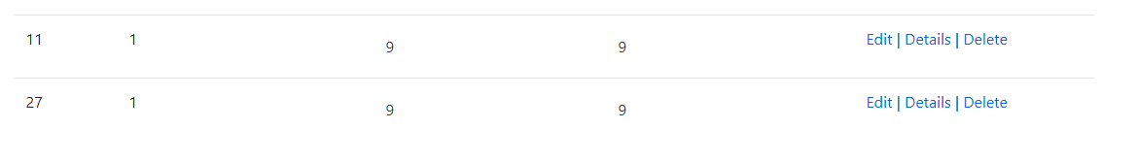

Before:



After:

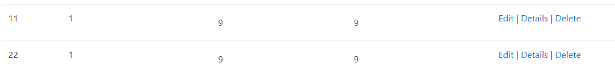

**Delete**

Before:



After:

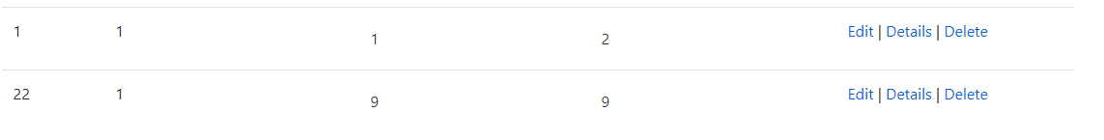

Before:



After:

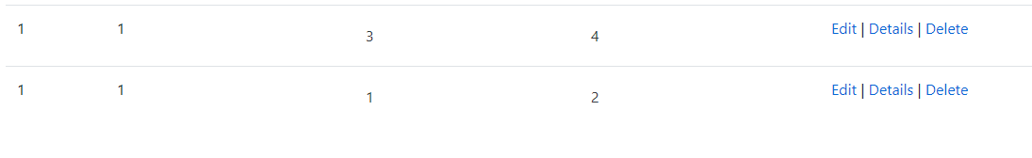

**Validation**

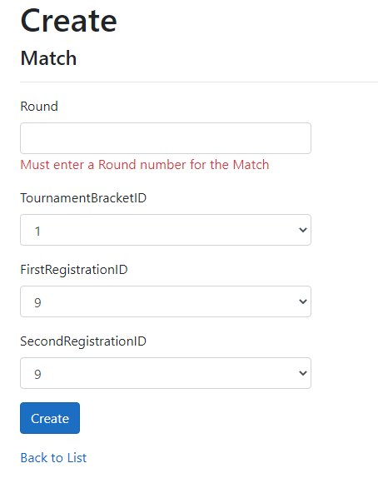

**Set Results**

**Create**

Before:

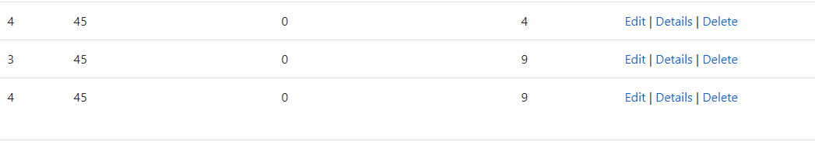

After:

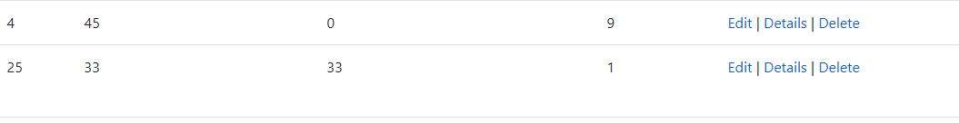

Before:



After:

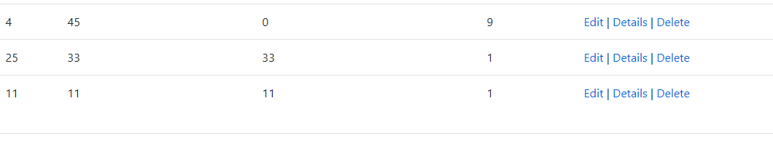

**Edit**

Before:



After:

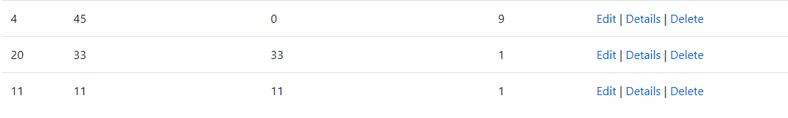

Before:



After:



Delete

Before:



After:



Before:



After:

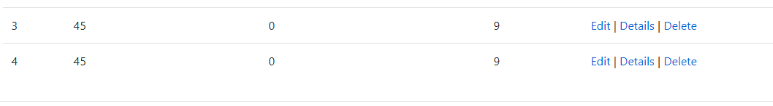

**Validation**

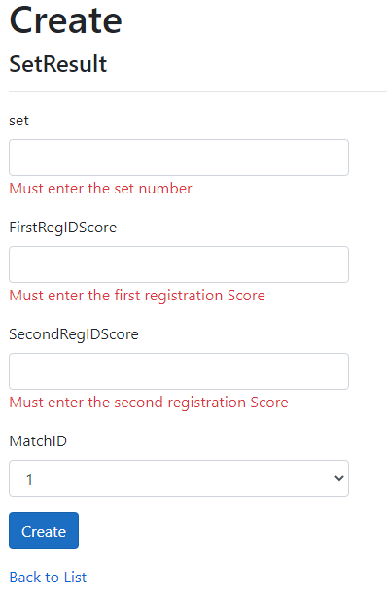

**Final Results**

**Create**

Before:

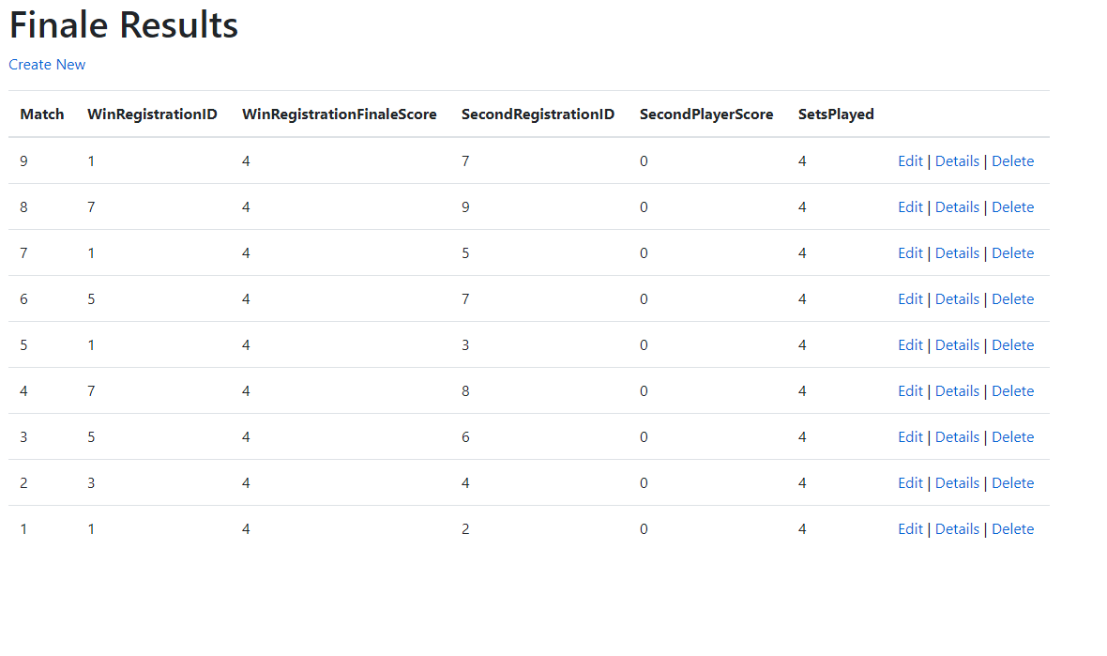

After:

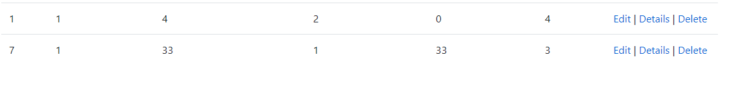

Before:



After:

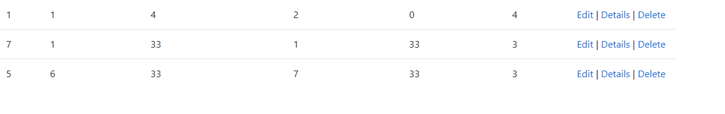

**Edit**

Before:



After:



Before:



After:

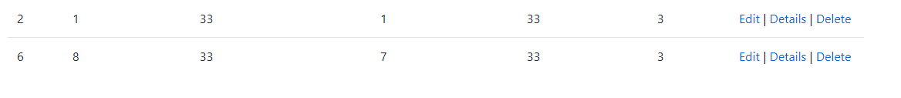

Delete

Before:

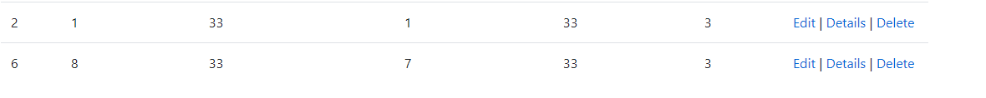

After:



Before:



After:

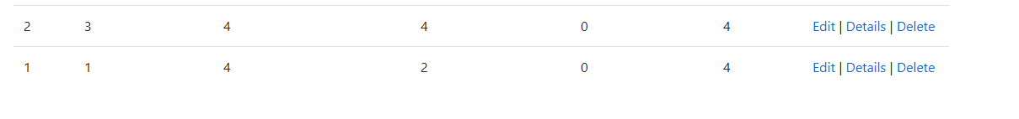

**Validation**

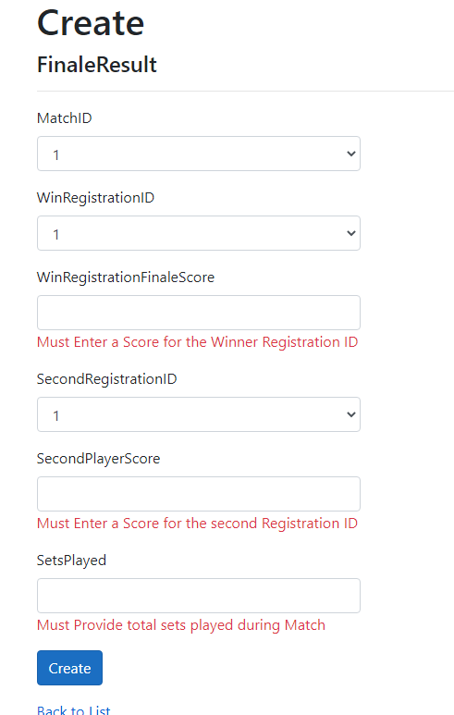

References

Tournaments | Tennis Australia. (2021). Retrieved 22 May 2021, from https://www.tennis.com.au/tournaments